Adventure Land:
The Offline Fantasy RPG with Code
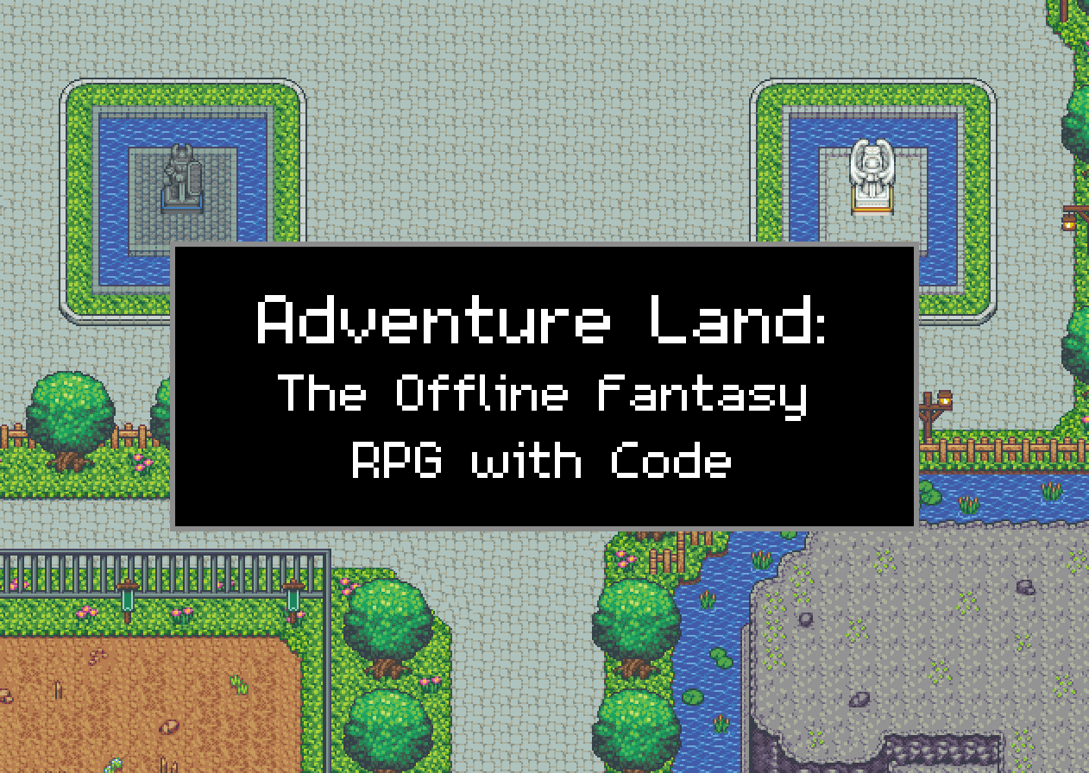
Player and Coding Guide
For version 28
How to install and play the game, the Mod Menu, the screen and its buttons, how the game works, learning to code from scratch, the built-in Party AIO and Bank Items List scripts, and a reference of every common CODE function.
This game is based on Adventure Land by Kaan Soral and the Adventure Land developers.

Contents
Every line below is a link: Ctrl+click it to jump to that section.
1. Welcome to Adventure Land
1.1 What you can do in the game
1.2 How this guide is organised
2. Installing and starting the game
2.1 What you need to install once
2.2 Starting the game
2.3 Character select and creating a character
2.4 Your first minutes
2.5 Stopping and saving
2.6 Where your game is kept, and backups
2.7 Updating to a newer version
3. A tour of the game screen
3.1 Moving, fighting and looting by hand
3.2 The tools row and its HIDE button
3.3 The skill boxes
3.4 The Mod Menu button and Win +
4. The Mod Menu
4.1 Opening it and finding your way around
4.2 Changing a setting
4.3 Combat
4.4 Monsters
4.5 Loot
4.6 Crafting & Gathering
4.7 Market
4.8 Characters
4.9 Holiday Events
4.10 The settings.txt file
5. Playing several characters at once
5.1 Limits
5.2 Running a lot of windows
6. How the game works
6.1 The classes
6.2 Stats you will see
6.3 Monsters and fighting
6.4 Items, the inventory and gear
6.5 Gold, shops and the people in town
6.6 The bank
6.7 Monster hunts (Daisy)
6.8 Events and event monsters
6.9 Parties
6.10 Maps and travel
6.11 Merchants and the market
6.12 Fishing and mining
7. Coding from zero
7.1 What a program is
7.2 Comments
7.3 Variables: remembering things
7.4 Doing sums and joining text
7.5 Making decisions with if
7.6 Lists (arrays)
7.7 Objects
7.8 Loops: doing something many times
7.9 Functions: your own commands
7.10 Repeating forever: setInterval
7.11 Things that take time: Promises, async and await
7.12 Reading errors
8. The CODE window
8.1 The code menu: default scripts and your slots
8.2 Running a script
8.3 Using one script inside another: load_code
8.4 The starter Default Code, line by line
9. The game's programming toolkit
9.1 character: you
9.2 Monsters, players and NPCs (entities)
9.3 G: the game's data book
9.4 The basic loop pattern
9.5 Events: reacting when something happens
9.6 Characters talking to each other
9.7 Seeing what your script is doing
10. The built-in party script: Party AIO
10.1 Setting it up, step by step
10.2 What every character does, in order
10.3 The leader: choosing, meeting and fighting
10.4 Followers: following and assisting
10.5 Roles and fighting styles
10.6 Hunt settings: what to kill
10.7 Potions
10.8 Inventory: loot, the merchant and the bank
10.9 The compounder (when the bank is full)
10.10 Getting un-stuck
10.11 How the party talks to itself
10.12 Common messages and what they mean
10.13 Your copy, updates and Reset
10.14 Party AIO settings at a glance
11. The built-in Bank Items List
11.1 What is inside it
11.2 Adding your items, step by step
11.3 How Party AIO uses the list
11.4 Finding item ids
11.5 Reset
12. Writing your own scripts, step by step
12.1 Step 1: say hello and show some facts
12.2 Step 2: a loop that keeps you alive
12.3 Step 3: fight the nearest monster of one type
12.4 Step 4: walk to the monsters if none are near
12.5 Step 5: restock potions when low
12.6 Step 6: put loot in the bank when the bag is full
12.7 Step 7: use a skill
12.8 Step 8: two characters working together
12.9 Building on Party AIO instead
13. Troubleshooting and tips
13.1 Good habits
Appendix A. CODE function reference, one example each
A.1 Writing messages and inspecting
A.2 Finding things
A.3 Moving
A.4 Fighting
A.5 HP, MP and potions
A.6 Inventory and items
A.7 Shops, gold and trading
A.8 Upgrading and compounding
A.9 The bank
A.10 Parties and other characters
A.11 Events and timing
A.12 Code slots, storage and keys
Appendix B. Useful ids and names
B.1 Common item ids
B.2 Monster ids for hunting
B.3 smart_move place names
Appendix C. Every setting in settings.txt
Appendix D. Glossary

1. Welcome to Adventure Land
Adventure Land: The Offline Fantasy RPG with Code is an offline, single-player version of Adventure Land, a pixel-art role-playing game that you can play in two ways: by hand with the mouse and keyboard, like any other RPG, or by writing small programs (called CODE) that play your characters for you. It is the same game as the online one, but with no other players. Everything runs on your own Windows PC, there is no account to sign up for, and nothing to buy.
This guide is written for someone who has never seen the game and has never written a line of code. Read it from front to back the first time. After that, use it as a reference: the contents page is clickable, and Appendix A has one worked example for every CODE function you are likely to use.
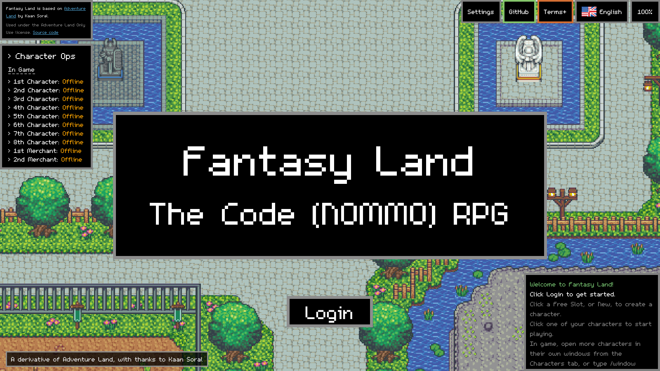
Figure 1. The title screen. Press Login (or Enter) to go to character select.

1.1 What you can do in the game
- Create up to 100 characters across 7 classes (Warrior, Paladin, Rogue, Ranger, Mage, Priest and Merchant).
- Fight monsters for experience (XP), gold and item drops, and level your characters up.
- Collect, upgrade and combine (compound) equipment to make your characters stronger.
- Buy and sell with the town's shopkeepers, store things in the bank, and run a merchant's market stall.
- Play several characters at once, each in its own game window, as a party that fights together.
- Change the rules of the game while you play with the Mod Menu (more XP, better drop luck, faster respawns, God Mode and much more).
- Write CODE so your characters hunt, heal, restock potions, bank loot and upgrade gear without you touching the keyboard. Two ready-made scripts, Party AIO and Bank Items List, are built in.

1.2 How this guide is organised
Part | What it covers
Chapter 2 | Installing Node.js and MongoDB, starting, stopping, saving and updating the game.
Chapter 3 | A tour of the game screen: every box and button, the HIDE buttons and the skill boxes.
Chapter 4 | The Mod Menu: every setting, what it does and what the numbers mean.
Chapter 5 | Playing several characters at once.
Chapter 6 | How the game works: classes, stats, combat, items, upgrading, the bank, shops, NPCs and events.
Chapters 7 to 9 | Learning to code from zero, the CODE window, and the game's programming toolkit.
Chapters 10 and 11 | The built-in scripts: Party AIO and Bank Items List, explained in detail.
Chapters 12 and 13 | Writing your own scripts step by step, then troubleshooting and tips.
Appendix A | Every common CODE function with one example each.
Appendices B to D | Useful ids and names, the settings file, and a glossary.

Note: All the pictures in this guide were taken from version 27 running with fresh characters called Hero (Warrior), Healer (Priest), Sparks (Mage) and Trader (Merchant). Your screen will look the same apart from names, levels and items, and the game's new name on the title screen and window titles.

2. Installing and starting the game

2.1 What you need to install once
Adventure Land is made of three parts that run on your PC: a database (MongoDB) that stores your saved game, a website and a game server (both run by Node.js), and the game window (Edge's WebView2) that shows it all. You install two programs once; the game does the rest.
Program | Why the game needs it | Where to get it
Node.js (LTS) | Runs the game's website and game server. | nodejs.org, the LTS download for Windows
MongoDB Community Server | The database that saves your account, characters, items, bank and CODE slots. | mongodb.com/try/download/community
Microsoft Edge / WebView2 | Draws the game window. | Already part of Windows 10 and 11

Installing Node.js
- Go to nodejs.org and download the LTS version for Windows (the .msi installer).
- Run it and click Next through the screens, accepting the licence. Keep the default options, including Add to PATH. You do not need the optional "Tools for Native Modules" box.
- Click Install, then Finish.

Installing MongoDB Community Server
- Go to mongodb.com/try/download/community, choose the current version, platform Windows and package msi, and download it.
- Run it, accept the licence and choose Complete.
- On the Service Configuration screen keep the defaults ("Install MongoD as a Service" is fine; the game runs its own copy of the database on a separate port, 27018, so the two never clash).
- MongoDB Compass is optional. Untick it if you do not want it.
- Click Install, then Finish.

Checking they installed
- Press the Windows key, type cmd and open Command Prompt.
- Type node -v and press Enter. You should see a version number such as v22.x. If you see "not recognised", reinstall Node.js with Add to PATH ticked, and restart the PC.
- MongoDB does not need to be on the PATH. Check that a folder like C:\Program Files\MongoDB\Server\8.0\bin exists and contains mongod.exe. The game looks there automatically.
Git is not needed: the shared engine the game uses is already in the game folder. Edge comes with Windows, so on almost every PC there is nothing else to install. If WebView2 is missing, the game opens in an ordinary Edge window instead.

2.2 Starting the game
- Extract the AdventureLand-Offline-v28 zip into a new, empty folder, for example C:\AdventureLand. Use a fresh folder rather than unzipping over an older copy.
- Double-click Adventure Land.exe.
- A small window shows progress while it starts the database, the website and the game server. The very first start also installs the game's packages and loads the maps, so it takes a few minutes. After that it is quick.
- The game opens in its own window on the title screen. Press Login (or Enter) to go to character select.
Watch out: The first time you run Adventure Land.exe, Windows may say "Windows protected your PC" because the file is not digitally signed. Click More info, then Run anyway. Windows only asks once. If Windows ever asks for admin rights or says "Destination Folder Access Denied" while unzipping, delete the old folder (or rename the zip) and unzip again into a fresh folder.

If a database, website or game server from another Adventure Land folder is still running (an older version, or a game that was ended from Task Manager), starting the game closes it first. The old database is shut down cleanly so its saves are kept, and this copy then runs its own files from its own folder.

2.3 Character select and creating a character
Character select shows your characters in pages of six. There are 100 slots, all free, on 17 pages: use the < and > buttons under the list to turn the pages (the middle button shows which page you are on, for example 1 / 17). Click a Free Slot (or New) to create a character, and click an existing character to play it. Up to 18 of them can be online at once.
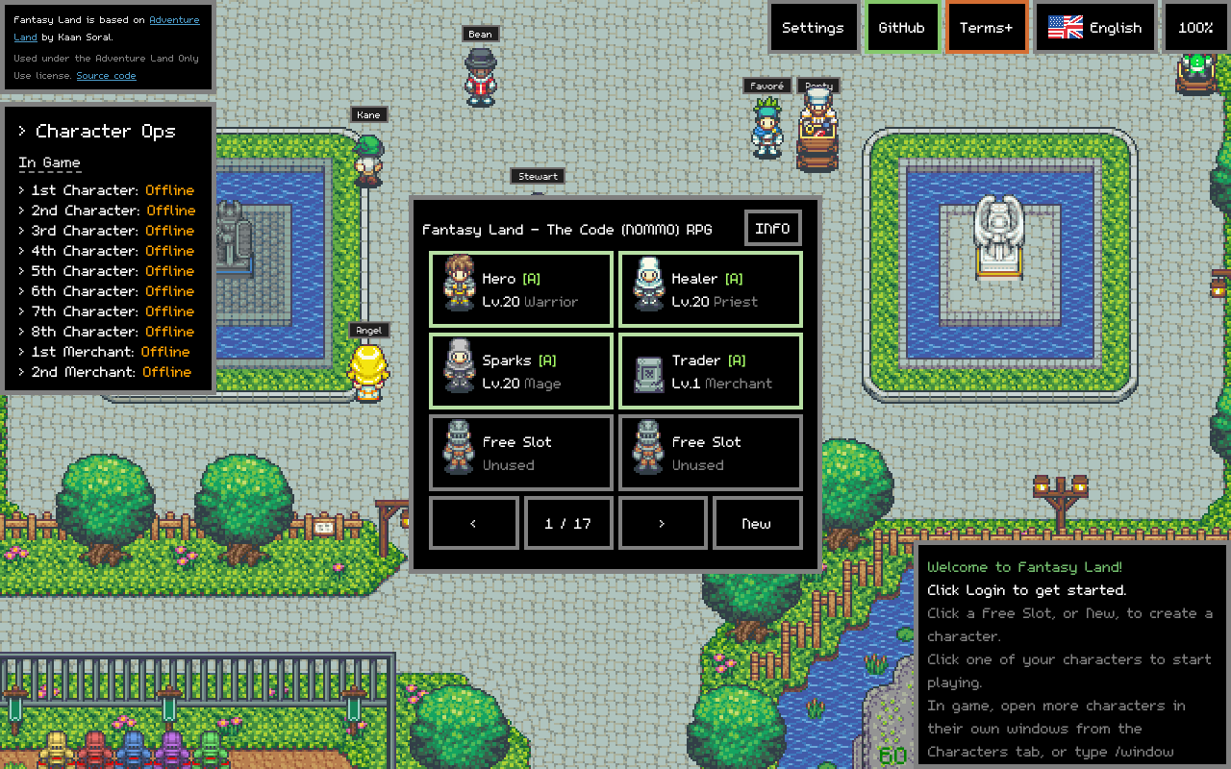
Figure 2. Character select, page 1 of 17, with the < and > page buttons and New underneath. The In Game box on the left shows which characters are online.
On the creation screen, type a name, pick a class and pick a look. Looks Opt. A to D are the game's originals; Opt. E to H are extra looks added in this offline version (a male and a female in light and dark skin for every class). Press Create.
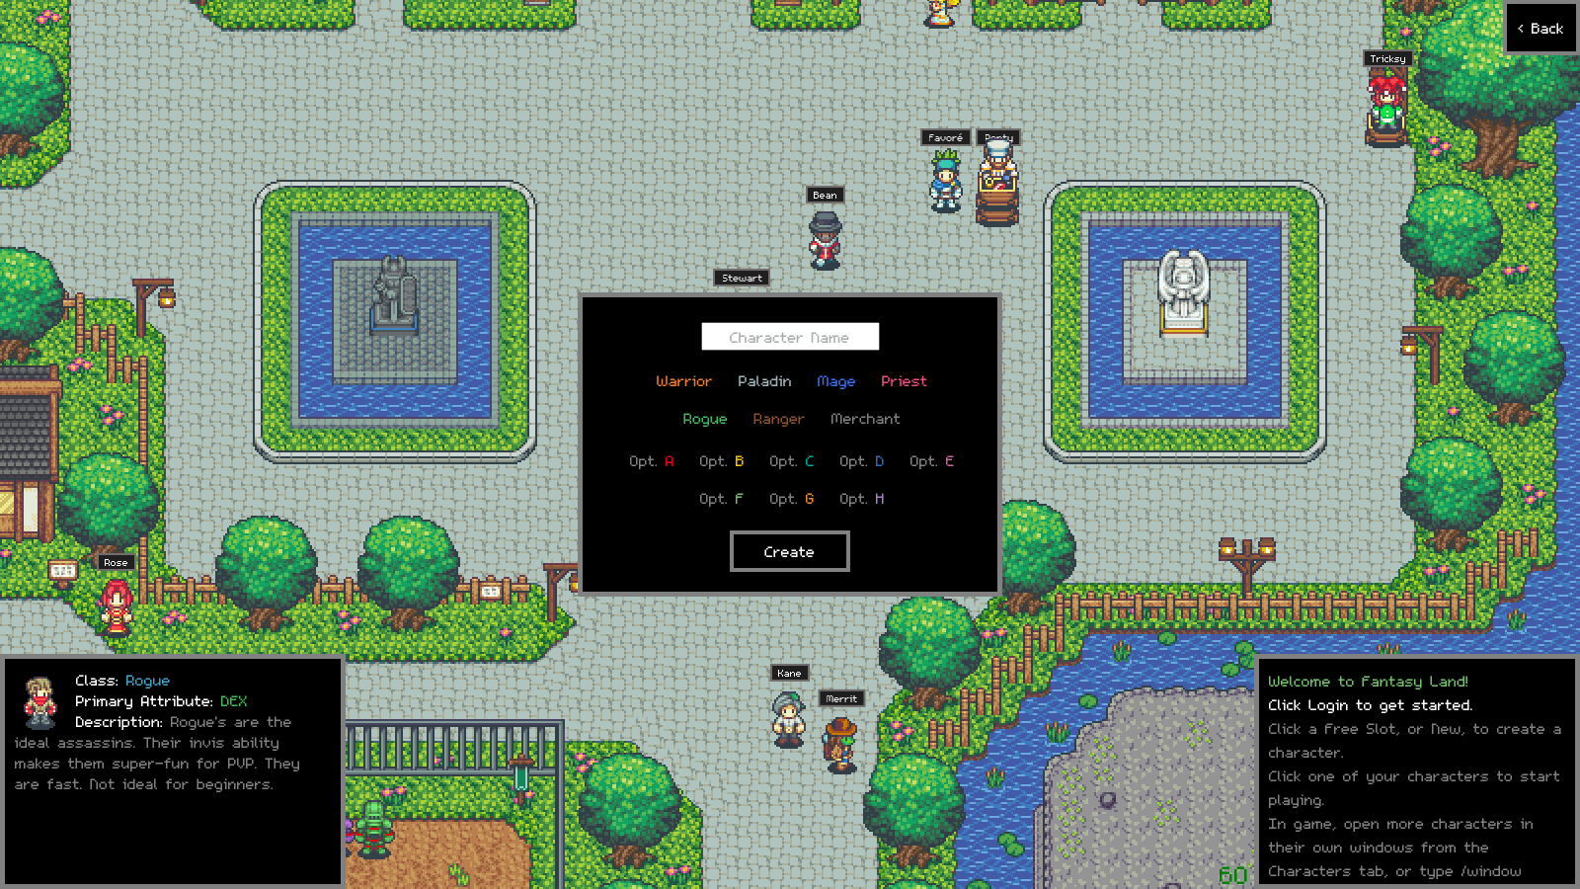
Figure 3. Creating a character: name box, the seven classes and looks Opt. A to H. The box at the bottom left describes the class you are hovering.
Not sure which class to pick? Chapter 7.1 compares them. For a first character a Ranger or Mage is easiest (they attack from a distance). A Warrior is very forgiving. A Merchant does not fight; it trades, upgrades and receives loot from your other characters.
The In Game box on the left of character select lists up to 8 fighting characters, then a 1st and 2nd merchant, and shows which are online. Character Ops at the top of that box lets you rename or delete characters. The Info button opens the Events page, which explains the holiday events.

2.4 Your first minutes
The first time a character enters the world, a short comic called The Voice in the Goo plays, followed by the tutorial lessons. You can read them (recommended) or press Skip and Close. The lessons can be reopened at any time from the TUTORIAL bar at the bottom right of the screen.
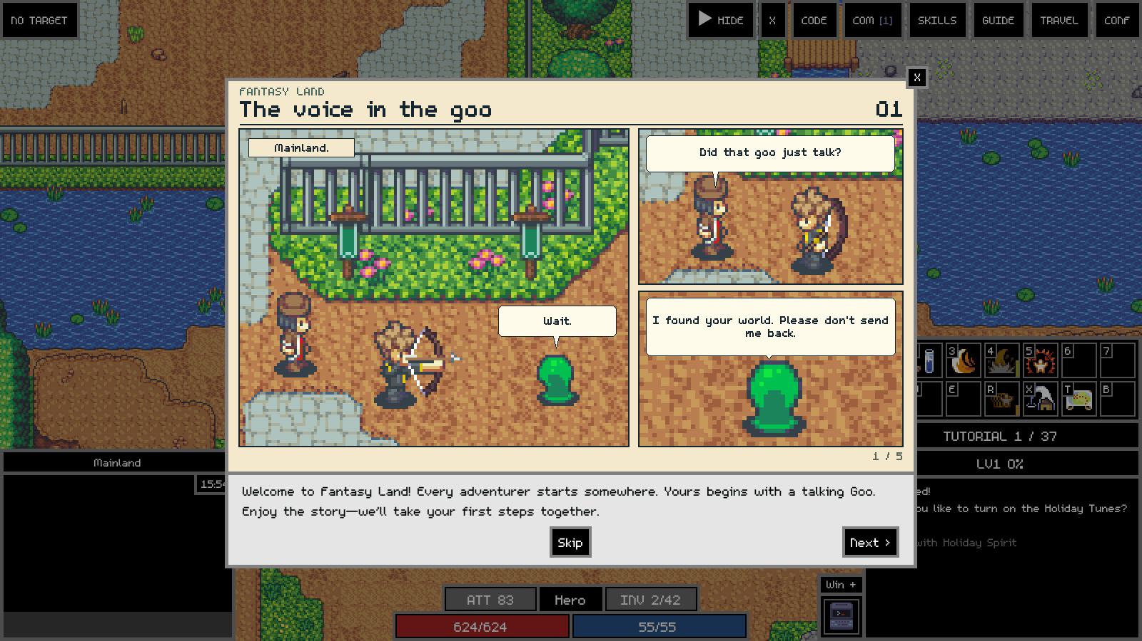
Figure 4. The opening comic. Next goes forward a page, Skip closes it.
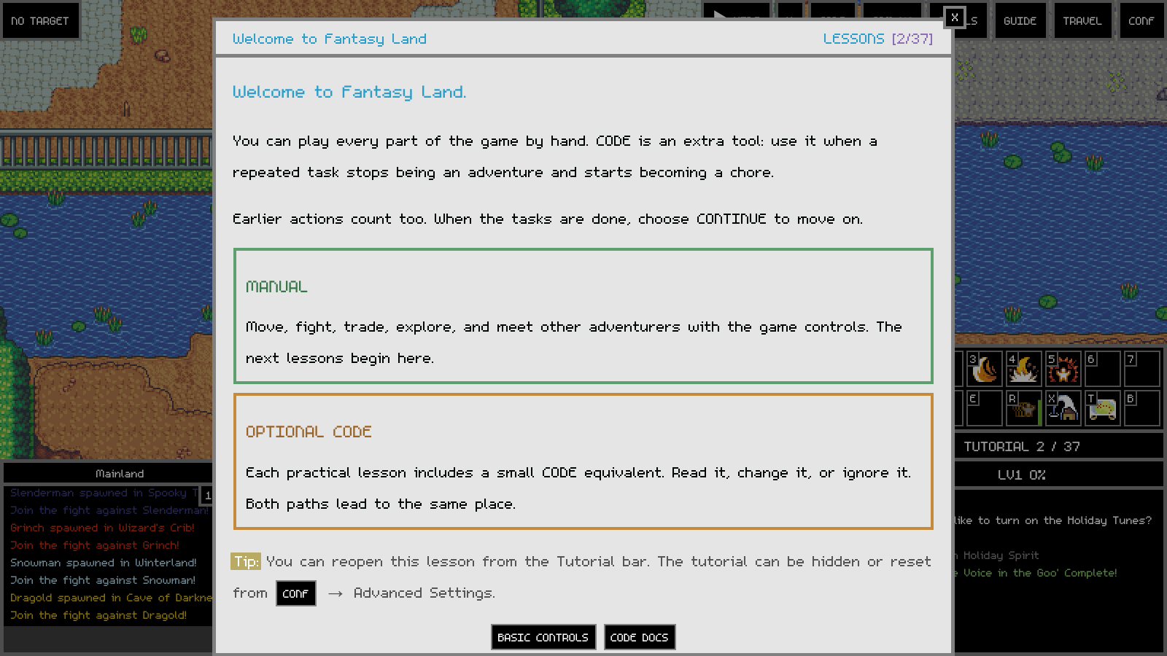
Figure 5. A tutorial lesson. Every lesson shows the manual way and the CODE way of doing the same thing.

2.5 Stopping and saving
Just close the game window. Adventure Land.exe shows "Saving your characters..." while it waits for everything to save, then closes itself. If several character windows are open, it waits until you close the last one. Your characters are also saved on the server while you play, so closing a window never loses progress.
Watch out: Do not end the game's processes in Task Manager. That stops the database without giving it a chance to save cleanly.

Play.bat and Stop.bat
These do the same job as Adventure Land.exe but with console windows you can see, which helps when something goes wrong. Play.bat starts everything in order and opens the game in an Edge window. Stop.bat closes the game window, waits a few seconds so your characters save, then stops the game server, website and database. When you start with Adventure Land.exe instead, those three write their messages to the logs folder.

2.6 Where your game is kept, and backups
Item | What it is
Adventure Land.exe | Starts the game and stops it when you close the last window.
Play.bat / Stop.bat | Start and stop with visible console windows.
settings.txt | All your game settings, including everything you set in the Mod Menu. Plain text, open it with Notepad.
singleplayer\data | Your saved game (the database): account, characters, items, bank and the scripts saved in the CODE window.
logs\ | Messages from the database, website and game server when started with Adventure Land.exe.
README.md, CHANGELOG.md | The readme and the list of changes by version.

The game's own program files are hidden so the folder only shows what you use. To see everything, open the folder in File Explorer and turn on View > Show > Hidden items.
To back up, close the game first, then copy singleplayer\data and settings.txt somewhere safe. Always copy them with the game closed, or the database copy may be incomplete.

2.7 Updating to a newer version
The game never updates itself; a new version comes as a new zip. The easiest way is to close the game, extract the new zip over your game folder (replace files when asked), and start Adventure Land.exe. Your settings.txt and saved game are kept because the zip contains neither. Alternatively, extract the new zip to its own folder and copy singleplayer\data and settings.txt from the old folder into it before you start it. New settings from a newer version are added to the end of your settings.txt automatically and your own values are kept.
The game uses three ports on your PC: the database on 27018, the website on 8090 and the game server on 7192. Only your PC can connect to them.

3. A tour of the game screen
Here is the screen while Hero, a Warrior, fights Goos with his party. Each numbered part is explained in the table below the picture.
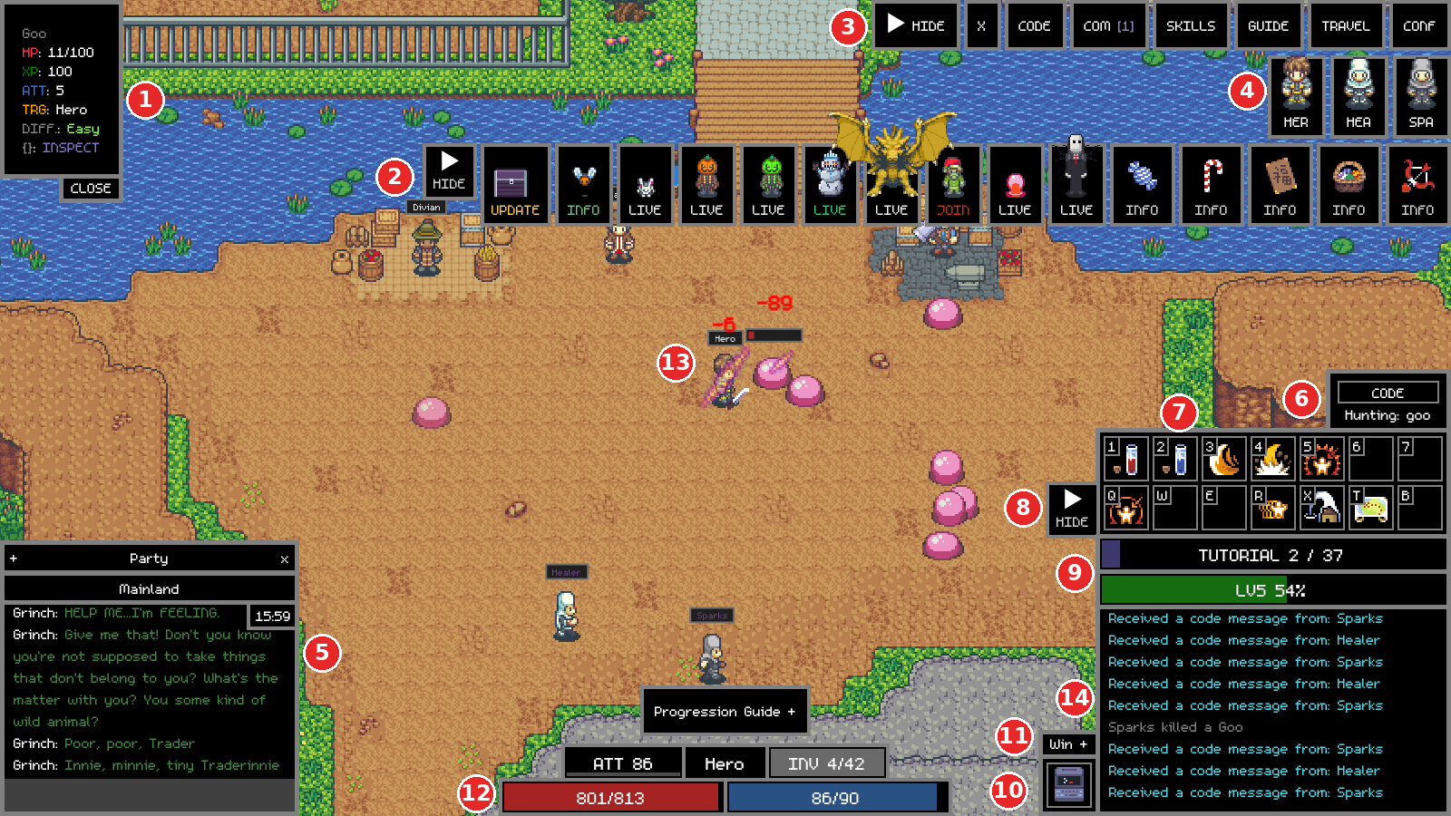
Figure 6. The game screen, numbered.
# | Part | What it does
1 | Target box | Shows the monster or player you have selected: its name, HP, the XP it gives, its attack, who it is targeting (TRG) and how hard it is (DIFF). INSPECT shows all its data. NO TARGET means nothing is selected.
2 | Events strip | One button per live event, boss and holiday (UPDATE, INFO, LIVE, JOIN, BEWARE). Hover or click for details. Its own HIDE button collapses it to a single EVENTS button.
3 | Tools row | X (snippet runner), CODE, COM (communicator), SKILLS, GUIDE, TRAVEL and CONF (settings). The HIDE button on its left collapses the row to a single TOOLS button.
4 | Party | Portraits of everyone in your party. Click one to select that character.
5 | Chat and map name | The name of the map you are on (here Mainland), then chat and what NPCs and event monsters say. Type here to chat or to use commands such as /window Name.
6 | CODE status box | Shows the message your running script set with set_message() (here "Hunting: goo"). It sits right above the skill boxes.
7 | Skill boxes | Fourteen boxes, two rows of seven: keys 1 to 7, then Q W E R X T B. Click a box or press its key to use what is in it.
8 | Skills HIDE button | Collapses the skill boxes to a single SKILLS button, and back.
9 | Tutorial and XP bars | The tutorial lesson you are on (click to open it), and your level with the percentage of the way to the next level.
10 | Mod Menu button | The computer icon. Opens the Mod Menu (Chapter 5).
11 | Win + button | Opens another game window on the character select page, so you can play another character at the same time.
12 | Status bars | Your attack (ATT, or HEAL for a priest), your name, how full your inventory is (INV 4/42), and your HP (red) and MP (blue).
13 | Your character | Damage numbers float above whoever was hit. A small bar under a name is that character's HP.
14 | Game log | Everything that happens: loot, gold, kills, level ups and every game_log() line from your CODE.

3.1 Moving, fighting and looting by hand
- Move by clicking the ground. Your character walks there (or as close as it can get).
- Select a monster, NPC or player by clicking it. Its details appear in the target box.
- Attack by clicking a monster once to select it, then clicking it again (or pressing the attack key). Your character keeps attacking while it is in range.
- Loot: monsters drop treasure chests. Click a chest to open it; the gold and items go into your inventory.
- Talk to an NPC by clicking it. Shopkeepers open their shop, others open their dialogue or exchange window.
- Use a potion with keys 1 (HP) and 2 (MP), or click the boxes.
- Go to town with X (the Town skill), which teleports you to the centre of the map after a short channel.

3.2 The tools row and its HIDE button
Figure 7. The tools row, open.
Button | What it opens
HIDE / TOOLS | Collapses the row to one TOOLS button, or brings it back.
X | A one-off snippet runner: type a line of CODE and run it once without touching your main script.
CODE | The CODE editor (Chapter 9).
COM | The communicator: your characters list (with Deploy links), merchants, chat and mail. The number in brackets is unread mail.
SKILLS | The full skills window, where you can see every skill and map skills to keys.
GUIDE | The in-game guides: tutorial lessons, item, monster, skill and recipe lists, and topic guides.
TRAVEL | Every NPC and monster on the map you are on, plus travel to other places.
CONF | Game settings (sound, interface options) and the Logout button in the top left, which returns to the title screen.

How the HIDE button works
Click HIDE (the arrow pointing right) on the left of the tools row and the whole row folds away into a single TOOLS button (arrow pointing left) in the top right corner. Click TOOLS to bring the row back. The events strip and the skill boxes have the same kind of button, labelled EVENTS and SKILLS when folded.
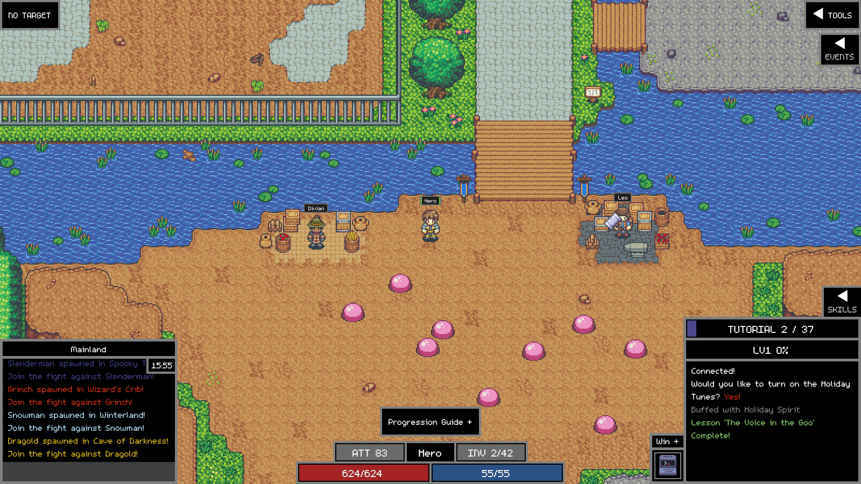
Figure 8. All three folded away: TOOLS and EVENTS in the top right, SKILLS above the tutorial bar. The game world has more room.
Each choice is remembered in that game window, so the next time you open the game the rows come back the way you left them. Folding a row only hides the buttons; nothing stops working. Your script keeps running, events still happen, and keyboard keys still use skills even while the skill boxes are hidden.

3.3 The skill boxes
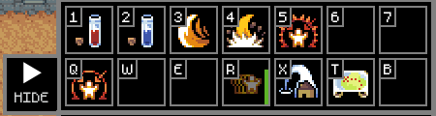
Figure 9. The skill boxes for a Warrior, with the HIDE button on their left.
The skill boxes are your quick-use bar. There are 14 boxes in two rows: the top row is keys 1 2 3 4 5 6 7 and the bottom row is Q W E R X T B. The small letter or number in the corner of each box is its key. Every box is always on show, even an empty one, so you can see at a glance which keys are free.

What is in the boxes
Each class starts with sensible defaults. For the Warrior above:
Key | Skill | What it does
1 | Use HP Potion | Drinks an HP potion from your bag.
2 | Use MP Potion | Drinks an MP potion.
3 | Cleave | Warrior: swing an axe to hit every enemy nearby (level 52, needs an axe).
4 | Stomp | Warrior: stun enemies nearby (level 52, needs a basher).
5 | Agitate | Warrior: taunt every monster nearby (level 68).
Q | Taunt | Warrior: pull one monster's attention onto you.
R | Charge | Warrior: a short burst of extra speed.
X | Town | Teleport to the centre of the map you are on.
T | Travel | Open the travel window.

Other classes get their own class skills in boxes 3 to 5 and Q (for example a Priest's include its healing skills). A skill the character is not high enough level for yet shows in its box but does nothing until you reach that level.

How to use them
- Press the key shown in the corner, or click the box.
- Skills that need a target (Taunt, Heal and so on) use whatever is selected in the target box.
- After use, a box darkens and refills as its cooldown runs; you cannot use it again until it is full.
- To change what is in a box, open SKILLS in the tools row. The top part shows your key mapping (pages 1, 2 and U for utility keys). Click a key box, then click the skill you want in it. You can also drag items and skills onto a box.
- Keys you have mapped beyond the 14 (for example on page 2 of the mapping) are added after the 14 boxes so they are visible too.
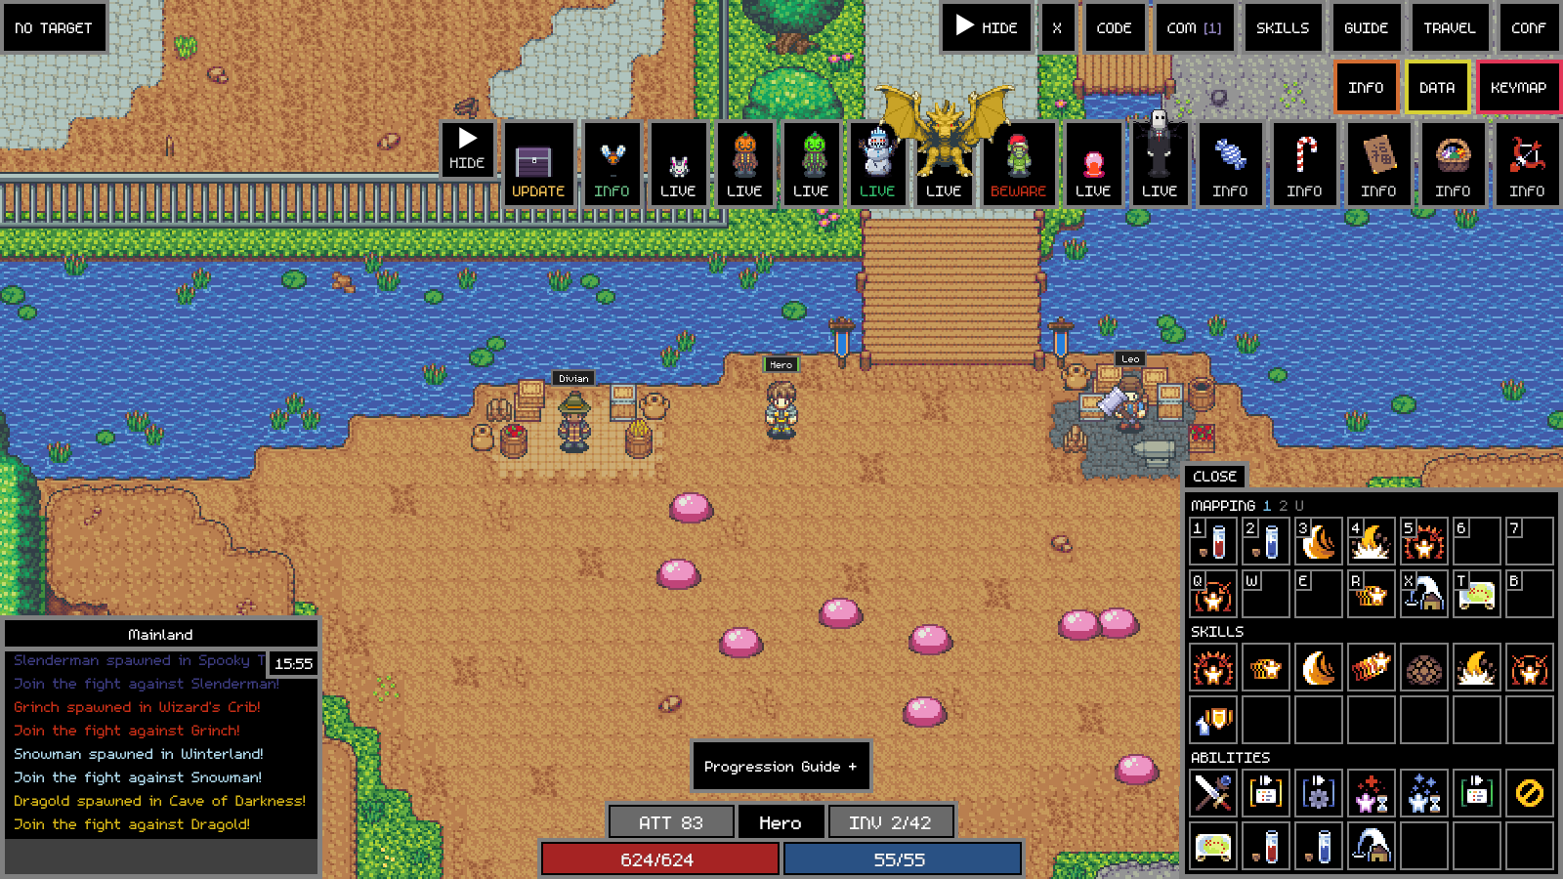
Figure 10. The SKILLS window: MAPPING at the top (the same 14 keys), then every skill and ability your class has.

The skills HIDE button
The HIDE button on the left of the skill boxes folds all of them into a single SKILLS button. Click SKILLS to unfold them. While the boxes are open, the tutorial bar, XP bar and game log below them line up to the same width. While they are folded, the keys still work, so you can hide the boxes and keep playing from the keyboard.

3.4 The Mod Menu button and Win +
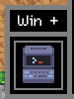
Figure 11. The Mod Menu button (the computer) with Win + on top.
The computer icon at the bottom of the screen, left of the game log, opens the Mod Menu (Chapter 5). The small Win + button sitting on top of it opens a new game window on the character select page, so you can log in another character alongside this one (Chapter 6).

4. The Mod Menu
The Mod Menu is where you change the rules of the game while you play. Want double XP, more drops, faster monster respawns, cheaper shops or characters that never take damage? It is all here. Every change applies straight away (two exceptions are marked below) and is saved to settings.txt in the game folder, so it is still set the next time you play.

4.1 Opening it and finding your way around
- Click the computer icon at the bottom of the screen, left of the game log.
- The menu opens on its home page: a list of seven groups. Each group shows either normal (nothing in it has been changed from the original game) or how many of its settings are changed, for example 2 changed.
- Click a group to open its page. Click < Back at the top left to return to the home page, or CLOSE to shut the menu.
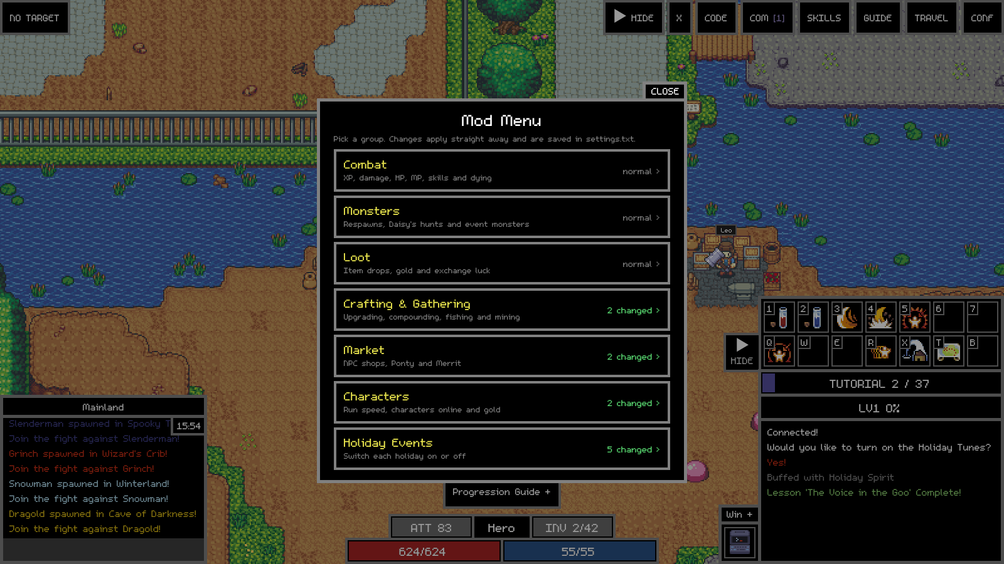
Figure 12. The Mod Menu home page. The right-hand side of each group counts the settings you have changed from the original game.

4.2 Changing a setting
- Number settings have a box on the right. Click it, type the new number and press Enter (or click somewhere else). The menu redraws with the saved value.
- On/off settings have an ON (green) or OFF (grey) button. Click it to flip it.
- A setting marked (after a restart) is saved straight away but only takes effect the next time you start the game.
- Typing something that is not a number, or a negative number, is ignored and the old value stays. A number above a setting's limit (for example Run speed above 5) is lowered to the limit, and settings that count things are rounded to whole numbers.

Multipliers and what the numbers mean
Most settings are multipliers. 1 means normal (exactly like the original game), 2 means double, 0.5 means half and 0 means none. For example XP multiplier 3 gives three times the XP for every kill; HP loss 0.5 means monsters only take half as much HP from you as they normally would. A few settings are plain numbers (minutes, counts or levels) and the menu says so under each one.
Tip: Settings change the whole game for every character at once, not just the window you changed them in.

4.3 Combat
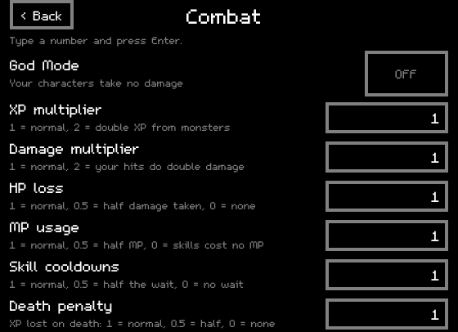
Figure 13. Combat settings.
Setting | What it does | Values
God Mode | Your characters take no damage at all: not from monsters, burns, traps or anything else. | ON / OFF
XP multiplier | Experience from monsters. | 1 normal, 2 double
Damage multiplier | Damage your characters deal to monsters. Hits roll as usual, then the multiplier applies. | 1 normal, 2 double, 0.5 half
HP loss | How much HP your characters lose when hit. | 1 normal, 0.5 half, 0 none
MP usage | How much MP attacks and skills cost. With 0.5 an attack that costs 100 MP costs 50. | 1 normal, 0.5 half, 0 free
Skill cooldowns | The wait before a skill can be used again. Monster skills are not changed. | 1 normal, 0.5 half, 0 no wait
Death penalty | The XP a character loses when it dies. | 1 normal, 0.5 half, 0 none

4.4 Monsters
Setting | What it does | Values
Respawn time | How long killed monsters take to come back, bosses and event monsters included. Changing it also speeds up respawns already waiting. | 1 normal, 0.5 twice as fast, 0 straight away
Daisy's tokens | Monster tokens Daisy gives for each finished monster hunt. | Whole number, default 1
Event Monsters: Grinch, Snowman, Mr Pumpkin, Mr Green, Slenderman, Dragold, Love Goo, Wabbit | Each event monster has its own switch. When ON it spawns even if its holiday is off. | ON / OFF

Watch out: Event monsters are bosses. They are switched ON in a new settings.txt, and they are far too strong for new characters. The Grinch also wanders into town and steals gold. Switch the ones you do not want OFF here, or use God Mode while you are low level.

4.5 Loot
Setting | What it does | Values
Drop luck | Chance of every item dropping, from every monster, everywhere. | 1 normal, 2 twice as likely, 0 nothing drops
Gold dropped | Gold from monsters. | 1 normal, 2 double
Drop everything | Every monster drops every item on its drop list on every kill. Very silly; overrides Drop luck. | ON / OFF
Exchange luck | Every exchange (Xyn, boxes, gems, quest items, class rewards), fishing, mining and monster chests. Every reward rarer than the most common one becomes this much more likely. | 1 normal, 2 rare rewards twice as likely
Exchange speed | How fast exchanges finish. | 1 normal, 2 double speed; 0.1 to 100

4.6 Crafting & Gathering
Setting | What it does | Values
Upgrade luck | Multiplies the success chance of upgrades. The chance shown in the upgrade window already includes it. | 1 normal, 2 twice the chance
Compound luck | The same for compounds. | 1 normal, 2 twice the chance
Crafting speed | How fast upgrades and compounds finish. Stacks with a merchant's Mass Production. | 1 normal, 2 double; 0.1 to 100
Safe upgrades | A failed upgrade keeps the item at its old level, and a failed compound keeps all three items. The scroll is still used up. | ON / OFF
Fishing and mining wait | OFF means you can fish and mine again straight away (each attempt still takes a few seconds). After a restart. | ON / OFF
Tools break | Whether fishing rods and pickaxes can break while you use them. | ON / OFF

4.7 Market
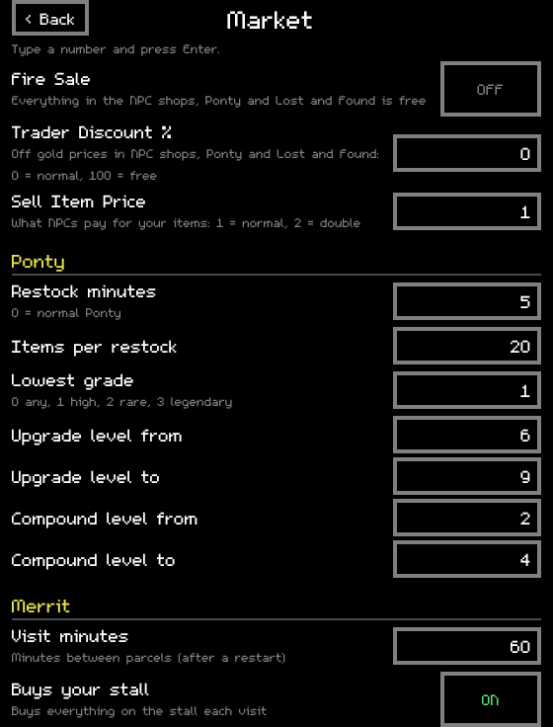
Figure 14. Market settings, including Ponty and Merrit.
Setting | What it does | Values
Fire Sale | Everything in the NPC shops, Ponty and Lost and Found costs nothing. | ON / OFF
Trader Discount % | Percent off the gold price in the NPC shops, Ponty and Lost and Found. Seashell prices are not changed. | 0 normal, 50 half price, 100 free
Sell Item Price | What NPCs (Gabriel and the other shops) pay you for your items. | 1 normal, 2 double
Ponty: Restock minutes | Ponty throws out his stock and restocks with random high-tier gear this often. | Minutes; 0 = normal Ponty
Ponty: Items per restock | How many items he puts on sale. | Up to 400
Ponty: Lowest grade | The lowest grade he stocks, judged at the level he stocks it. | 0 any, 1 high, 2 rare, 3 legendary
Ponty: Upgrade level from / to | Weapons and armour he stocks are upgraded to a random level in this range. | 0 to 12
Ponty: Compound level from / to | Rings, earrings, amulets and so on are compounded to a random level in this range. | 0 to 7
Merrit: Visit minutes | Merrit brings a parcel to each merchant's open stall this often (each merchant has its own timer). After a restart. | Minutes, default 60
Merrit: Buys your stall | On each visit Merrit buys everything for sale on the stall at the price you set. Only the stall is emptied, never the bag. Merchants get XP from these sales. | ON / OFF

4.8 Characters
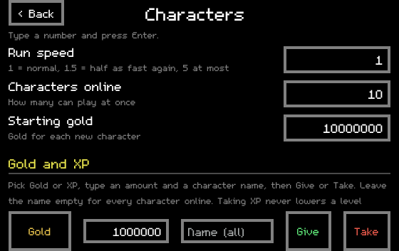
Figure 15. Characters settings and the Give / Take line.
Setting | What it does | Values
Run speed | How fast your characters run. | 1 normal, 1.5 half as fast again, 5 at most
Characters online | How many of your characters can be logged in at once, merchants included (at most 2 merchants). | 1 to 18
Starting gold | Gold every new character starts with. Counts for the next character you create, no restart needed. | Default 10,000,000

Give / Take gold and XP
- Click the first button to choose Gold (yellow) or XP (blue).
- Type an amount in the next box.
- Type a character's name in the Name box to change only that character, or leave it empty to change every character online.
- Press Give to add, or Take to remove.
Taking never goes below zero, and taking XP only removes progress within the current level; it never lowers a level. Giving XP levels a character up as usual. The amounts you type are remembered in settings.txt as give_gold and give_xp, so you can press Give again and again.

4.9 Holiday Events
Five switches: Holiday Season, Lunar New Year, Valentine's, Halloween and Egg Hunt. A holiday that is ON stays on all year. Holidays control their special drops, decorations and event icons; their bosses are switched separately in the Monsters group. The holidays were designed to run one at a time, so if something looks odd, turn some off.

4.10 The settings.txt file
Everything in the Mod Menu is stored in settings.txt in the game folder, plus a few extras. You can edit it with Notepad when the game is closed: every line is explained inside the file, lines starting with # are notes, and yes/no values are written yes or no. Save the file and start the game again. If you delete settings.txt, a fresh one with default values is made on the next start. Appendix C lists every setting.
A few lines of settings.txt
# Experience from monsters. A multiplier: 1 = normal,
# 2 = double XP, 0.5 = half.
xp_rate = 1

# God Mode: your characters take no damage at all.
god_mode = no

5. Playing several characters at once
Every character plays in its own game window. You can have several windows open at once and they all play in the same world, so they can party up, trade and help each other. Any of these opens another window:
How | What to do
Win + button | Click the small Win + on top of the Mod Menu icon. A new window opens on character select; click a character.
Characters list | Open COM in the tools row, then the Characters tab, and click Deploy next to an offline character.
Chat | Type /window CharacterName. /window on its own opens the character select page.
CODE | Run open_character_window("CharacterName").

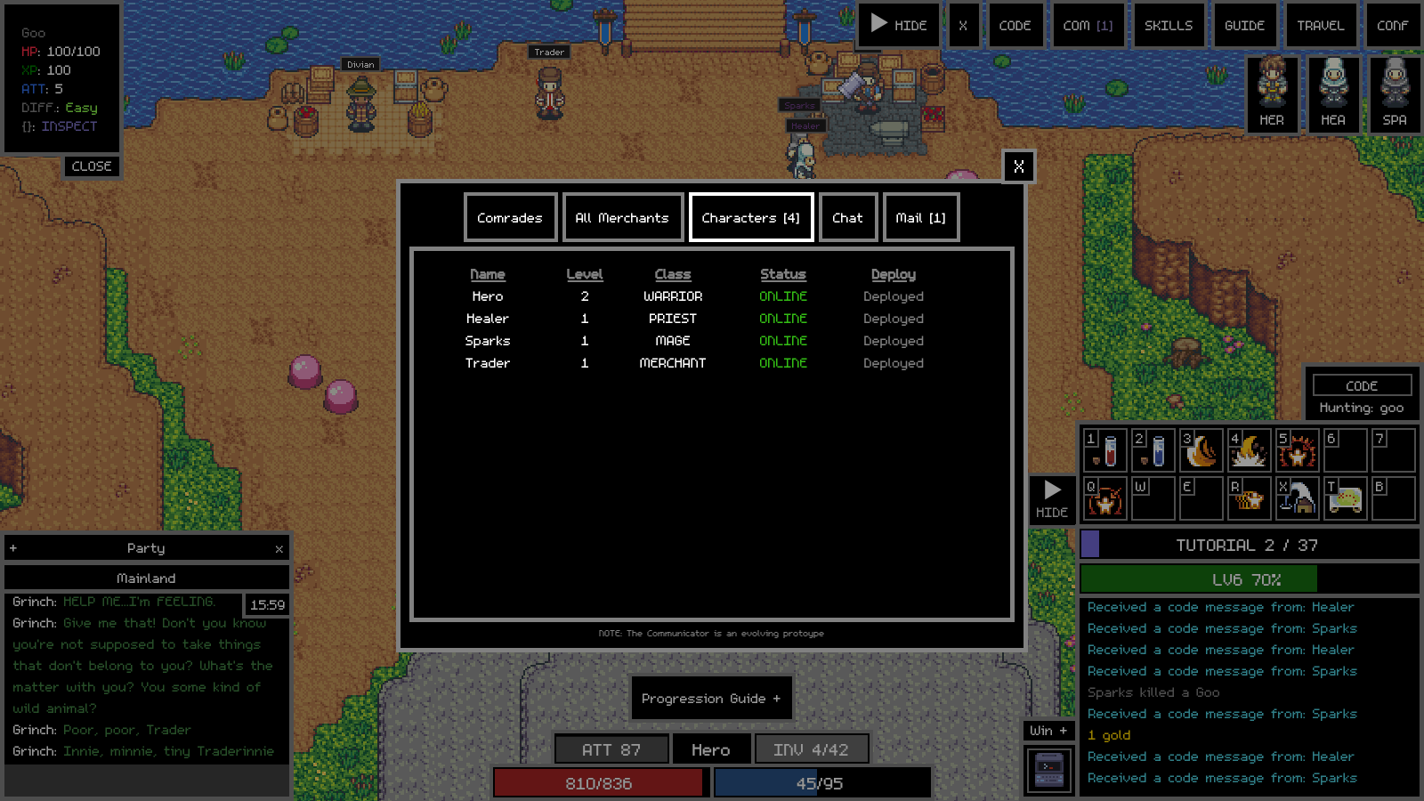
Figure 16. COM > Characters. Deploy opens an offline character in its own window.

5.1 Limits
- Characters online in the Mod Menu sets how many can be online together, merchants included, up to 18.
- Up to 2 merchants can be online at the same time.
- Opening one character more than the limit allows (or a 3rd merchant) is turned away, and that window's log says why.
- You can make up to 100 characters, and all 100 slots are free.

5.2 Running a lot of windows
Each window uses roughly as much memory and processor time as a browser tab running a game, and the game does not stop you at a hardware limit. Watch for the game or PC stuttering (especially when many characters fight at once), windows freezing or closing when memory runs out, and on a laptop extra heat, fan noise and battery drain. If things get slow, close a window or two; nothing is lost. Game windows keep running at full speed when they are in the background or minimised, so your CODE keeps working.
The first window's title shows the game's name and your character's name; extra windows do the same, so you can tell them apart on the taskbar. Every window, the first one included, runs as its own copy of Adventure Land.exe, so you can close them in any order and closing one never affects the others. The game saves and stops when the last window closes.

6. How the game works
This chapter explains the game itself: what the numbers mean, how fights work, how items get better, and who all the people in town are. You need this to play by hand, and you need it even more to write CODE, because your script makes the same decisions you would.

6.1 The classes
Class | Main stat | Fights | Base HP / MP | Good to know
Warrior | Strength | Melee (range 18) | 200 / 20 | Tough, forgiving, high damage. Taunts monsters off friends. Easy first character.
Paladin | Strength | Melee (range 15) | 300 / 50 | Very tanky; heals itself, uses maces. Slower attacks.
Rogue | Dexterity | Melee (range 15) | 120 / 30 | Fast, hard-hitting, can go invisible. Not ideal for beginners.
Ranger | Dexterity | Ranged (bow) | 160 / 60 | Long range and multi-shots. Very good for beginners.
Mage | Intelligence | Ranged magic (range 120) | 70 / 300 | Fragile but strong from a distance; easy to play. Can give MP to others.
Priest | Intelligence | Ranged magic (range 120) | 70 / 300 | The healer. Low damage but every serious party needs one.
Merchant | - | Barely fights | 40 / 200 | Trades, runs a market stall, upgrades and compounds faster. Levels up by selling.

Your main stat is the one that boosts your damage the most. All classes get HP from Vitality. Gear with your main stat on it is what you want.

6.2 Stats you will see
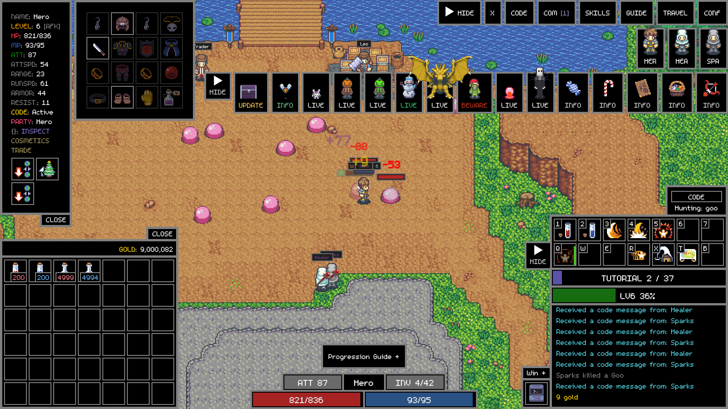
Figure 17. The character window (top left, opened with C) and the inventory (I). Gold is shown above the bag.
Stat | Meaning
HP / Max HP | Hit points. At 0 the character dies.
MP / Max MP | Mana. Every attack and skill costs some MP.
Level and XP | Killing monsters gives XP; enough XP gives a level. Each level raises your stats.
ATT (attack) | Average damage per hit. Priests show HEAL instead.
ATTSPD / frequency | How often you attack. Higher is faster.
RANGE | How far away you can hit from. Ranged classes have much more.
RUNSPD (speed) | How fast you walk.
ARMOR / RESIST | Reduce physical / magical damage you take.
STR, DEX, INT, VIT, FOR | Strength, Dexterity, Intelligence, Vitality (more HP), Fortitude (more armour and resistance).
Luck, Gold %, XP % | Better drops, more gold, more XP.

6.3 Monsters and fighting
Monsters live in spawn areas on each map. Each type has its own HP, attack, XP and drops. Easy ones near town (Goo, Bee, Crab, Snake, Squig, Tortoise) suit new characters; harder ones are further out. The TRAVEL window lists every monster on the map you are on, and the target box shows a monster's difficulty.
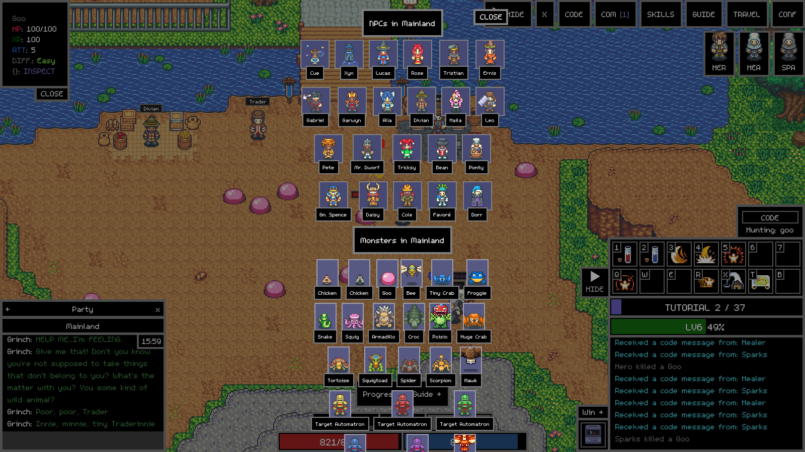
Figure 18. TRAVEL lists NPCs and monsters in the current map (here Mainland). Click one to see details.
- A monster that is attacking you shows your name as its target (TRG). Most monsters only attack when attacked; some attack anything nearby.
- You can only hit something that is in range. Melee classes must walk up; ranged classes can stay back. Kiting means stepping back while attacking so a melee monster cannot reach you.
- Every attack costs a little MP and has a cooldown set by your attack speed.
- When a monster dies it drops a chest. Open it (click, or loot() in CODE) to get gold and items. In a party, loot is shared.
- The killer and its party earn XP. Party members nearby share XP.

Dying and respawning
At 0 HP a character dies (it shows as a ghost and character.rip is true in CODE). After a short wait you can respawn in town (a button appears, or respawn() in CODE). Dying costs some XP (see Death penalty in the Mod Menu).

Potions
Item id | Name | Restores | Price
hpot0 | HP Potion (small) | 200 HP | 20 gold
hpot1 | HP Potion | 400 HP | 100 gold
mpot0 | MP Potion (small) | 300 MP | 20 gold
mpot1 | MP Potion | 500 MP | 100 gold

Potions are sold by the potion shop in town (smart_move("potions") walks there). Keys 1 and 2 drink them. HP and MP potions share one short cooldown. Your character also regenerates slowly on its own.

6.4 Items, the inventory and gear
Your inventory (bag) has 42 slots. Things that stack (potions, scrolls, materials) take one slot for up to 9,999 of them. Gear goes into equipment slots: main hand, off hand, helmet, chest, pants, gloves, shoes, cape, two rings, two earrings, amulet, belt, orb and so on.

Grades
Every piece of gear has a grade that depends on the item and its upgrade level: normal, high, rare and legendary. The higher the grade, the better the scroll you need to improve it.

Upgrading
Weapons and armour are upgradable, from +0 up to +12. To upgrade, go to Cue in town (smart_move("upgrade")), put the item and an upgrade scroll in the upgrade window and confirm. Each attempt has a chance of success shown in the window. Success raises the level by one; failure normally destroys the item. The scroll is always used up.
Scroll | Item id | For | Price
Upgrade Scroll | scroll0 | Normal grade | 1,000
High Upgrade Scroll | scroll1 | High grade | 40,000
Rare Upgrade Scroll | scroll2 | Rare grade | 1,600,000
Compound Scroll | cscroll0 | Normal grade | 6,400
High Compound Scroll | cscroll1 | High grade | 240,000
Rare Compound Scroll | cscroll2 | Rare grade | 9,200,000

Compounding
Accessories (rings, earrings, amulets, belts, orbs and similar) are compoundable. Three identical items at the same level plus a compound scroll make one item one level higher. Failure normally loses all three. Scrolls are sold by Lucas next to Cue (smart_move("scrolls")).
Tip: Turn on Safe upgrades in the Mod Menu and failures never destroy anything (only the scroll is used). Upgrade luck and Compound luck raise the odds, and Crafting speed makes each attempt finish faster.

Exchanging
Some items are exchangeable: boxes, gems, eggs, quest items, tokens. Xyn in town (smart_move("exchange")) opens them and gives you a random reward from a table. Exchange luck makes the rarer rewards more likely, and Exchange speed makes it quicker.

6.5 Gold, shops and the people in town
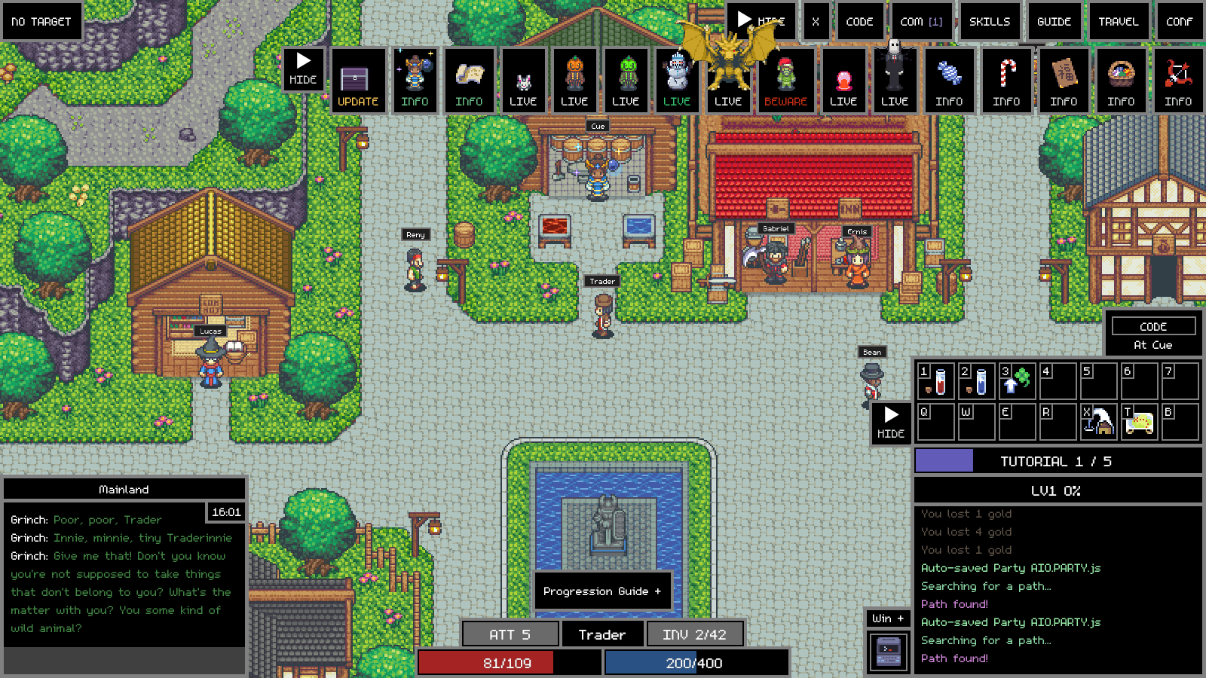
Figure 19. Town: Cue (upgrades and compounds) in the middle, Lucas (scrolls) on the left, Gabriel and Ernis under the red roof.
NPC | What they do
Gabriel | Buys your items for gold. Sell Item Price in the Mod Menu multiplies what he and the other shops pay.
Shopkeepers | Sell potions, basic weapons and armour, scrolls and other supplies. Trader Discount and Fire Sale change their prices.
Cue | Upgrades and compounds.
Lucas | Sells upgrade and compound scrolls.
Xyn | Exchanges boxes, gems and other exchangeable items.
Ponty | The second-hand stall. In this offline version he restocks with random high-grade, pre-upgraded gear every few minutes (5 by default).
Lost and Found | Sells items that were lost or destroyed.
Daisy | Hands out monster hunts (6.7).
Merrit | Visits merchants' market stalls, brings parcels and (with Buys your stall) buys what is for sale.
Bank tellers | In the bank building: store items and gold.
Favoré | Sells a server blessing (more XP, gold and luck for 3 days) for seashells.
Mr. Dworf / Haila | Cosmetic boxes for a random look, paid in seashells.

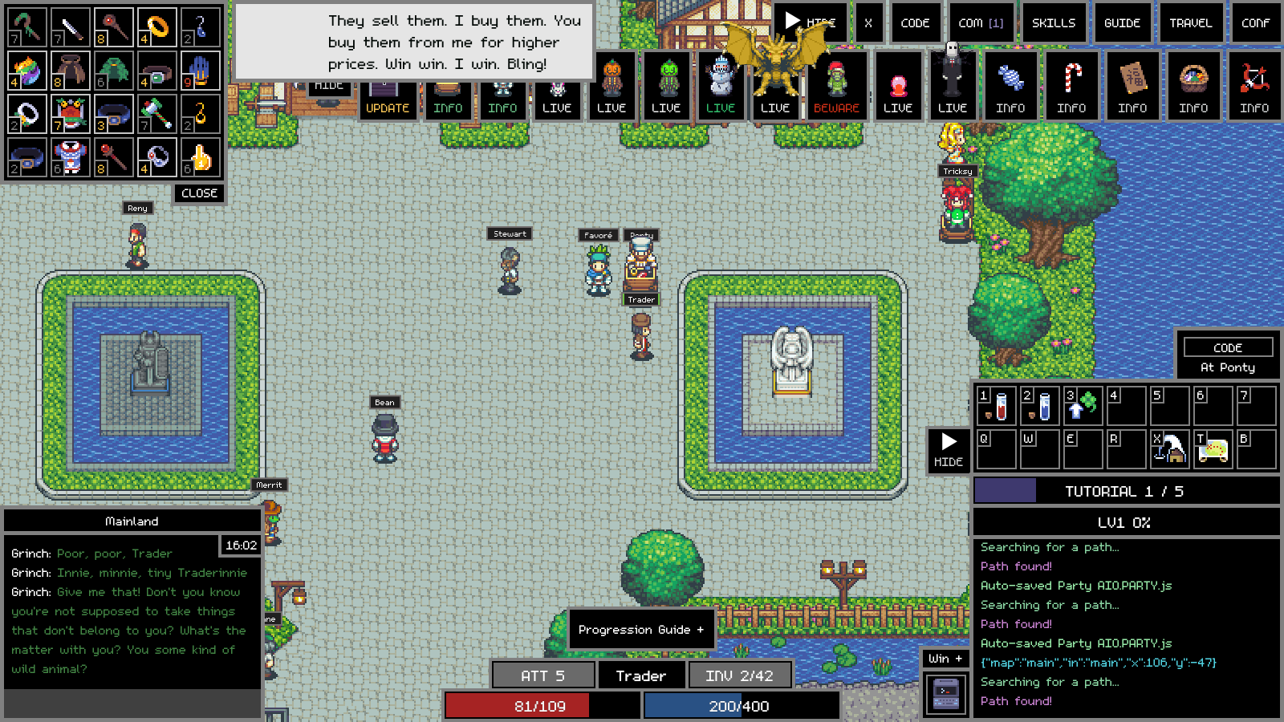
Figure 20. Ponty's stock after a restock: high-grade gear, each with its upgrade or compound level in the corner.
This offline version has no Shells (the online game's paid currency). Anything that cost Shells now takes seashells from your bag, at 625 seashells for every 75 Shells. Seashells drop from monsters and come from exchanges.

6.6 The bank
The bank is a building on the main map (smart_move("bank")). Inside, your items and gold are safe, and every character on your account shares the same bank. Items stored by one character can be taken out by another. The bank is split into packs (items0, items1 and so on) of 42 slots each; more packs can be bought with gold or seashells.
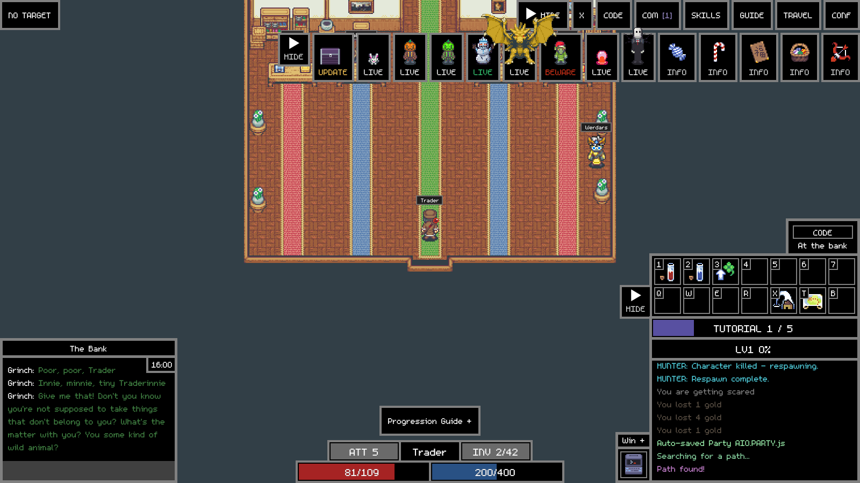
Figure 21. Inside the bank.
By hand you click a teller to open the bank and drag items in and out. In CODE you use bank_store(), bank_retrieve(), bank_deposit() and bank_withdraw(), which only work while you are inside the bank.

6.7 Monster hunts (Daisy)
Daisy in town gives you a monster hunt: kill a number of one monster type within a time limit. Finish it and return to Daisy for monster tokens (how many is set by Daisy's tokens in the Mod Menu), which you can exchange for rewards. In CODE, your current hunt is character.s.monsterhunt (.id is the monster, .c the number left).

6.8 Events and event monsters
The events strip at the top of the screen shows every live event: holidays, bosses (Grinch, Snowman, Mr Pumpkin, Mr Green, Slenderman, Dragold, Love Goo, Wabbit), and daily or nightly events. LIVE means it is happening now; JOIN means you can join it; BEWARE means a dangerous monster is roaming. Click a button for details. Holidays and event monsters are switched in the Mod Menu. Killing an event boss drops special chests.

6.9 Parties
Up to several characters can be in a party. Party members share XP and loot, see each other in the party portraits, and can heal and buff each other. Invite with the target box or send_party_invite("Name"); accept with accept_party_invite("Name"). The Party AIO script (Chapter 10) does all of this for you.

6.10 Maps and travel
The world is made of maps: Mainland (main, the starting map with the town), Winterland, Desertland, the Halloween island, caves, tunnels and dungeons. Maps connect through doors and teleporters. TRAVEL shows where you can go; smart_move() in CODE finds a path for you across maps. The Town skill (key X) takes you to the centre of the map you are on.

6.11 Merchants and the market
A Merchant opens a market stall (needs a Merchant Stand) on the town square and lists items for sale at prices it sets. With Merrit: Buys your stall ON, Merrit buys everything on each merchant's stall on every visit and the merchant earns the gold and XP. Merchants are also where the Party AIO sends loot and gold, and they upgrade and compound faster with Mass Production.

6.12 Fishing and mining
With a fishing rod or pickaxe equipped, you can fish at water spots and mine at rock spots for materials and rare finds. Fishing and mining wait and Tools break in the Mod Menu remove the wait between tries and stop tools breaking. Exchange luck also improves what you find.

7. Coding from zero
CODE in Adventure Land is written in JavaScript, the same language that runs web pages. You do not need to install anything: the game has its own editor and runs your script for you. This chapter teaches just enough JavaScript to read and write game scripts. Type the examples into the CODE window as you go (Chapter 8 shows how) and watch what they do.

7.1 What a program is
A program is a list of instructions the computer follows in order, top to bottom, exactly as written. It does not guess what you meant. If you misspell a word or forget a bracket it stops and shows an error. That sounds harsh, but it also means a program does exactly the same thing every time, which is what makes it good at chores like hunting monsters for hours.
Your first program. game_log writes a line in the game log.
game_log("Hello, Adventure Land!");

Each instruction usually ends with a semicolon ;. Text in double quotes is a string (a piece of text). game_log is a function: a named action that the game provides. You call a function by writing its name followed by brackets, with any information it needs inside the brackets.

7.2 Comments
Anything after // on a line is a comment. The computer ignores it; it is a note for people. Putting // in front of a line of code is called commenting it out, and is the usual way to switch a line off without deleting it. Both built-in scripts use this a lot.
// This whole line is a note.
game_log("This runs");
// game_log("This does not run, it is commented out");

7.3 Variables: remembering things
A variable is a named box that holds a value. You create one with var (or let), give it a name and put a value in it with =. Later you can read it or put something else in it.
var monster = "goo"; // a string
var kills = 0; // a number
var attack_mode = true; // a boolean: true or false

kills = kills + 1; // now kills is 1
game_log("Killed " + kills + " " + monster); // Killed 1 goo

Kind of value | Examples | Used for
Number | 0, 42, 3.5, -10 | HP, gold, distances, counts
String (text) | "goo", 'Hero' | Names, monster types, messages. Single or double quotes both work.
Boolean | true, false | Yes/no switches, like the settings at the top of Party AIO
Array (list) | ["goo", "bee"] | Several values in order, like FOLLOWERS or BANK_ITEM_IDS
Object | { type: "goo", kills: 100 } | Several named values together, like one entry in the monster list
null / undefined | null | "Nothing here", for example when no monster is found

Names are case-sensitive: Kills and kills are different boxes. Use letters, numbers and underscores, and do not start with a number.

7.4 Doing sums and joining text
var hp = 300;
var max_hp = 400;
var percent = hp / max_hp * 100; // 75
var half = max_hp / 2; // 200
var message = "HP is " + percent + "%"; // + joins strings

The usual operators work: + - * /, plus % (the remainder after dividing). + adds numbers but joins strings. x++ adds 1 to x, x-- takes 1 away, and x += 5 adds 5.

7.5 Making decisions with if
An if runs some code only when a condition is true. else runs when it is false. The condition goes in round brackets and the code to run goes in curly brackets.
if (character.hp < character.max_hp / 2) {
game_log("Under half HP - drinking a potion");
use_skill("use_hp");
} else {
game_log("HP is fine");
}

Comparison | Means
a == b or a === b | a equals b (=== is stricter and preferred)
a != b or a !== b | a does not equal b
a < b, a > b | less than, greater than
a <= b, a >= b | less than or equal, greater than or equal
a && b | both a AND b are true
a || b | a OR b (or both) is true
!a | NOT a: true when a is false (or empty, 0, null)

Watch out: One = puts a value in a box; two or three == / === compare. Writing if (hp = 0) is a classic mistake: it sets hp to 0 instead of checking it.

7.6 Lists (arrays)
An array holds values in order. Positions are counted from 0, so the first item is [0]. .length tells you how many there are, and .push() adds one to the end.
var targets = ["goo", "bee", "crab"];
game_log(targets[0]); // goo
game_log(targets.length); // 3
targets.push("snake"); // now 4 items

// This is exactly how the Bank Items List works:
var BANK_ITEM_IDS = [];
BANK_ITEM_IDS.push("vitring");

Your inventory is an array too: character.items has 42 positions (0 to 41). An empty slot holds null.

7.7 Objects
An object groups named values (called properties) in curly brackets. Read a property with a dot.
var entry = { type: "goo", kills: 100 };
game_log(entry.type); // goo
entry.kills = 200;

// The game gives you objects all the time:
game_log(character.name + " is level " + character.level);

The ROLES setting in Party AIO is an object whose properties are arrays. MANUAL_MONSTER_LIST is an array of objects.

7.8 Loops: doing something many times
// Count from 0 to 4
for (var i = 0; i < 5; i++) {
game_log("Number " + i);
}

// Look at every inventory slot
for (var s = 0; s < character.items.length; s++) {
var item = character.items[s];
if (item) game_log("Slot " + s + ": " + item.name);
}

A for loop has three parts: the starting value, the condition to keep going, and what to do after each pass. while (condition) { ... } repeats as long as the condition is true. break leaves a loop early and continue skips to the next pass.

7.9 Functions: your own commands
You can make your own functions to give a name to a group of instructions, then call them whenever you need them. A function can take inputs (parameters) and give back a result with return.
function hp_percent(who) {
return who.hp / who.max_hp * 100;
}

if (hp_percent(character) < 50) {
game_log("Low HP!");
}

7.10 Repeating forever: setInterval
A game script needs to keep checking the world: is there a monster nearby, is my HP low, is my bag full? The usual way is setInterval, which runs a function again and again with a pause between runs. The pause is in milliseconds (1000 ms = 1 second).
setInterval(function () {
if (character.rip) return; // dead: do nothing this time
use_hp_or_mp(); // drink a potion if needed
loot(); // open nearby chests
}, 250); // 4 times a second

return inside the function ends this run early; the interval still calls it again next time. This "check, act, wait, repeat" loop is the heart of almost every game script, including the built-in ones.

7.11 Things that take time: Promises, async and await
Some actions are not instant. Walking to the bank, buying an item or using a skill has to go to the game server and come back. These functions return a Promise: a ticket that says "I will tell you when this is done, and whether it worked".
Inside a function marked async, you can put await in front of a call to wait for it to finish before moving to the next line. That lets you write step-by-step plans in order:
async function restock() {
await smart_move("potions"); // walk to the potion shop, wait until there
await buy("hpot1", 100); // buy 100 HP potions, wait for the reply
await smart_move("goo"); // walk back to the goos
game_log("Restocked!");
}
restock();

If an awaited action fails (no path, not enough gold, out of range), the Promise is rejected. Catch the failure with try / catch so your script carries on instead of stopping:
async function go_bank() {
try {
await smart_move("bank");
game_log("In the bank");
} catch (error) {
game_log("Could not get to the bank: " + (error.reason || error));
}
}

Without await you can use .then() and .catch(): smart_move("bank").then(function () { game_log("there"); });. Both styles appear in the built-in scripts. sleep(ms) is a Promise too: await sleep(1000) pauses an async function for one second.

7.12 Reading errors
- Syntax errors (a missing bracket or quote) stop the script from starting. The game log shows the error and the line number.
- ReferenceError: x is not defined means you used a name that does not exist. Usually a typo, or wrong capital letters.
- TypeError: cannot read properties of null means you tried to use something that was empty, for example target.hp when no target was found. Check with if (target) first.
- When a game action fails, the error object has a reason, for example not_in_range, no_path, cooldown or bank_full. Log it with error.reason.
- Press F12 in the game window to open the browser's developer tools; the Console tab shows every error with details.

8. The CODE window
Click CODE in the tools row. The editor opens on the left half of the screen with the script for the slot you last used. A DOCS panel at the bottom lets you search the game's built-in documentation.
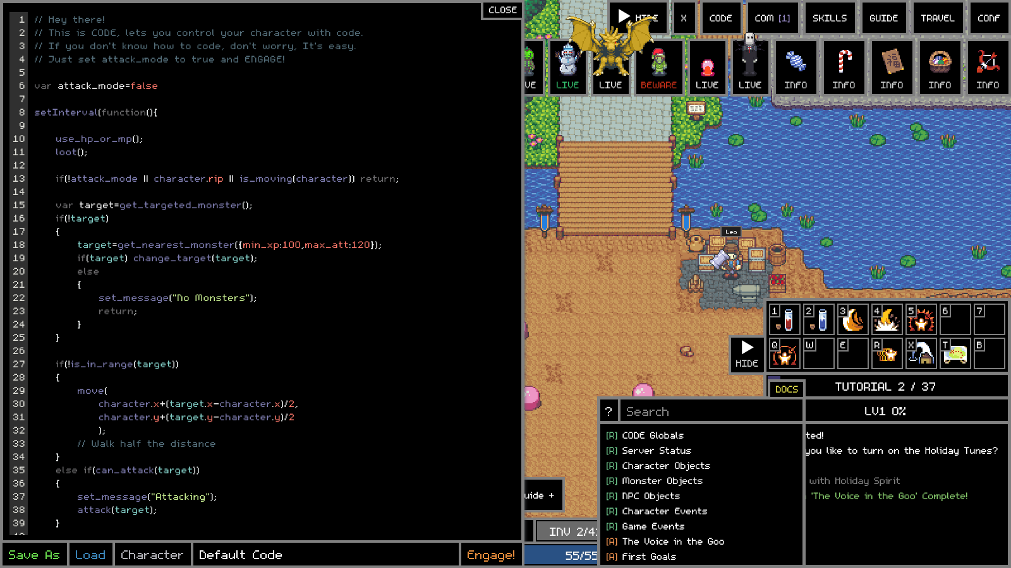
Figure 22. The CODE editor with the starter Default Code, and the DOCS search panel at the bottom right.
Part | What it does
Editor | Type your script here. Line numbers on the left match the numbers in error messages. Colours show strings, numbers and game functions.
Save As | Saves the script in the editor into a numbered slot with a name (type a slot number and a name, then Save). Saved scripts are kept in the database and are available to every character.
Load | Opens the code menu (below) to pick a saved script or a default script.
Slot name | Shows which slot is in the editor, for example Party / Party AIO.
Engage! / Disengage | Engage starts running the script that is in the editor. Disengage stops it. Only one script runs per character at a time.
CLOSE | Hides the editor. A running script keeps running.
DOCS | Search the documentation: type a function name and click a result.

8.1 The code menu: default scripts and your slots
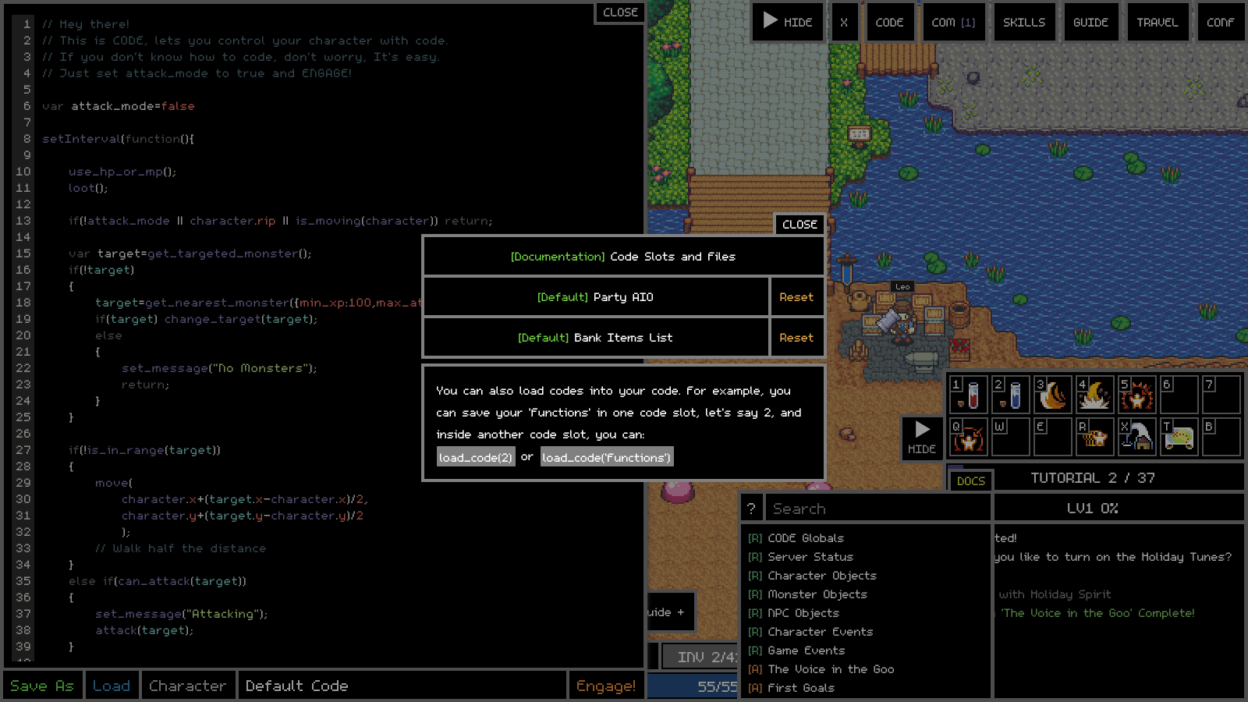
Figure 23. Load opens the code menu: the documentation link, the two default scripts with Reset buttons, then your numbered slots.
The menu starts with [Documentation] Code Slots and Files, then the two default scripts that come with Adventure Land, then your own numbered slots:
- [Default] Party AIO: the all-in-one party hunting script (Chapter 10).
- [Default] Bank Items List: the list of items Party AIO always banks (Chapter 11).
Click a name to load it into the editor. The default scripts are ordinary editable scripts kept in their own slots (PARTY and BANKLIST). Type your changes and press Save, and your copy is kept. Your saved copy is also what load_code("Party AIO") and starting a character from the CODE window use.

The Reset button
Each default script has a Reset button on the right of its row. It asks first, in a small box with Confirm and Cancel, so a stray click cannot wipe anything. Confirm loads the original script into the editor. Your saved copy is only replaced when you then press Save, so if you change your mind just load your copy again.
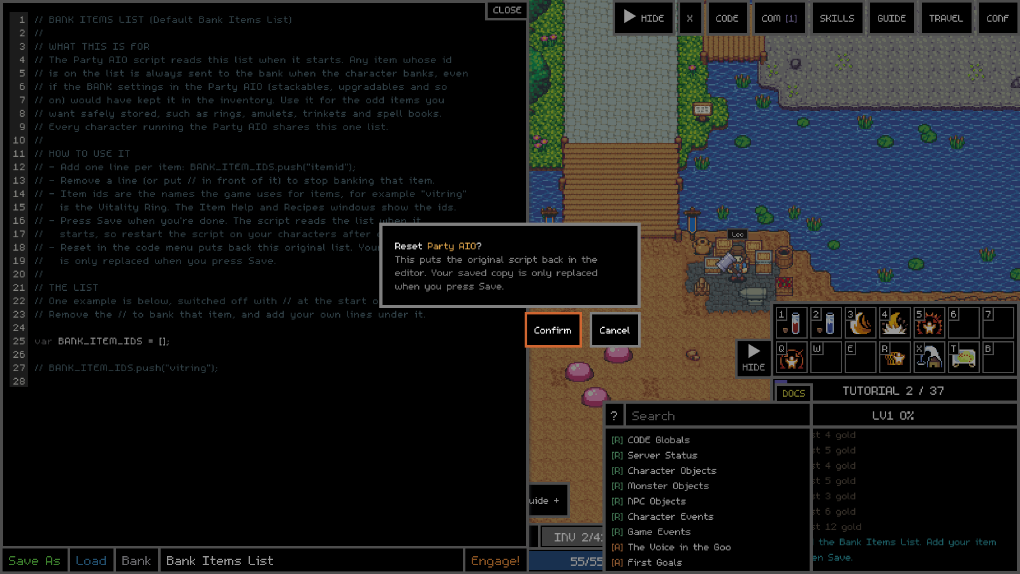
Figure 24. The Reset confirmation.

8.2 Running a script
- Open CODE and load (or type) the script.
- Press Engage!. The button changes to Disengage, and the CODE status box above the skill boxes shows what the script says it is doing.
- Watch the game log for messages from the script.
- Press Disengage to stop. Edit, then Engage again to run the new version.
To run the same script on several characters, open each character's window and Engage the same slot, or from one character's CODE call start_character("Name", "Party AIO") to start another character in the background (see Appendix A).

8.3 Using one script inside another: load_code
load_code("name") or load_code(number) runs another saved slot inside the current script, as if its text were pasted in at that point. That is how Party AIO reads the Bank Items List. You can use it to keep your own helper functions in one slot and share them between scripts.
// Slot 2, saved with the name "Functions"
function hp_percent(who) { return who.hp / who.max_hp * 100; }

// Slot 3, your main script
load_code("Functions");
game_log("HP is " + hp_percent(character) + "%");

8.4 The starter Default Code, line by line
New characters start with this short script. It is a complete, working hunter and a perfect first thing to read.
Default Code
var attack_mode=false

setInterval(function(){

use_hp_or_mp();
loot();

if(!attack_mode || character.rip || is_moving(character)) return;

var target=get_targeted_monster();
if(!target)
{
target=get_nearest_monster({min_xp:100,max_att:120});
if(target) change_target(target);
else
{
set_message("No Monsters");
return;
}
}

if(!is_in_range(target))
{
move(
character.x+(target.x-character.x)/2,
character.y+(target.y-character.y)/2
);
// Walk half the distance
}
else if(can_attack(target))
{
set_message("Attacking");
attack(target);
}

},1000/4); // Loops every 1/4 seconds.

Line(s) | What it means
var attack_mode=false | A switch. While it is false the script only drinks potions and loots. Change it to true and Engage to start fighting.
setInterval(function(){ ... },1000/4) | Run everything inside four times a second, forever.
use_hp_or_mp(); loot(); | Drink a potion if HP or MP is low, and open any chests nearby.
if(!attack_mode || character.rip || is_moving(character)) return; | Stop this run early if fighting is switched off, the character is dead, or it is still walking.
get_targeted_monster() | The monster you already have selected, if any.
get_nearest_monster({min_xp:100,max_att:120}) | Otherwise, the closest monster worth at least 100 XP that hits for at most 120.
change_target(target) | Select it, as if you clicked it.
set_message("No Monsters") | Show a short message in the CODE status box.
is_in_range(target) / move(...) | If it is too far away, walk half the distance towards it (the next run walks the next half).
can_attack(target) / attack(target) | If it is in range and the attack cooldown is ready, attack.

Tip: Try it: load the Default Code, change false to true on the first line, stand near some Goos and press Engage.

9. The game's programming toolkit
Your script can see the game world through a handful of objects, and act on it through functions. This chapter covers the objects and the ideas; Appendix A lists the functions one by one with examples.

9.1 character: you
character is your own character, always up to date. The most useful properties:
Property | Meaning
character.name, .ctype, .level | Name, class ("warrior", "mage"...) and level
character.hp, .max_hp, .mp, .max_mp | Current and maximum HP and MP
character.xp, .max_xp | XP so far this level and XP needed for the next
character.x, .y, .map | Where you are
character.gold | Gold you are carrying
character.items | Your inventory: an array of 42 slots, each an item object ({name, q, level}) or null
character.slots | What you have equipped: character.slots.mainhand, .helmet, .ring1 and so on
character.rip | true while dead
character.target | The id of whatever you have selected
character.party | Your party leader's name (undefined when not in a party)
character.range, .speed, .attack, .armor, .resistance | Your current stats
character.s | Your conditions and timers, for example character.s.monsterhunt (Daisy's hunt)
character.bank | Your bank's contents, only while you are inside the bank

9.2 Monsters, players and NPCs (entities)
Everything you can see on the map is an entity. They are all in parent.entities, an object keyed by id. You usually get them through helper functions instead: get_nearest_monster(), get_targeted_monster(), get_player("Name"), get_monster(id) and get_target_of(entity). A monster entity has mtype (its type, such as "goo"), hp, max_hp, attack, xp, x, y, target (who it is attacking) and dead.
var m = get_nearest_monster({ type: "bee" });
if (m) {
game_log(m.mtype + " has " + m.hp + "/" + m.max_hp + " HP, " +
Math.round(distance(character, m)) + " away");
}

9.3 G: the game's data book
G holds every fixed fact about the game: G.items (every item: name, type, price, stats), G.monsters (every monster's stats and drops), G.skills, G.classes, G.maps, G.npcs. It never changes while you play. show_json(G.items.hpot1) shows an item's data in a window.
var info = G.items["vitring"];
game_log(info.name + " sells for " + info.g + " gold"); // Ring of Vitality ...

9.4 The basic loop pattern
Nearly every hunting script follows the same plan. Learn this shape and you can read any of them:
- Every few hundred milliseconds:
- If dead, respawn and stop this run.
- Drink potions if needed, and loot.
- If busy (walking, restocking, banking), stop this run.
- If the bag is nearly full or potions are low, go to town and sort it out.
- Find a target. If there is none, walk to where the monsters are.
- If the target is out of range, move closer (or, for ranged classes, keep your distance).
- If the attack is ready, attack. Use skills when they make sense.
Party AIO (Chapter 10) is this exact plan, written out carefully for a whole party with lots of safety checks.

9.5 Events: reacting when something happens
Besides checking in a loop, your script can listen for things as they happen:
// Something was hit anywhere nearby
game.on("hit", function (data) {
if (data.actor == character.id && data.kill) game_log("I killed something!");
});

// Another of your characters sent this one a code message
character.on("cm", function (m) {
game_log(m.name + " says " + JSON.stringify(m.message));
});

// Built-in event functions you can define:
function on_party_invite(name) { accept_party_invite(name); }

Party AIO uses game.on("hit") to count kills and character.on("cm") for the party to talk to each other.

9.6 Characters talking to each other
send_cm("Name", data) sends a code message (any data you like) to another of your characters that is running CODE. The receiver gets it through character.on("cm"). The game log shows "Received a code message from: Name" each time, which is normal (Party AIO sends several a second). Other ways to work together: send_item(), send_gold(), send_party_invite(), and get_party() to see where every member is.

9.7 Seeing what your script is doing
Tool | Use it for
game_log("text") | A line in the game log. Add a colour as a second argument, for example game_log("Low HP", "red").
set_message("text") | The short status in the CODE box above the skill boxes. Good for "what am I doing now".
show_json(anything) | Opens a window showing an object's contents, for example show_json(character.items).
draw_circle(x, y, r) | Draws a circle on the map, for example to show your attack range.
The X button | Run one line once without touching your main script, for example show_json(character.slots).
F12 Console | The browser's developer console, with full error details.

10. The built-in party script: Party AIO
Party AIO (All In One) is a complete script that runs a whole party of your characters. You run the same script on every character. At the top you type who the leader is, who follows, and what role each one plays. Each character reads that, works out its own job, and gets on with it:
- The leader chooses which monster to hunt (from your list, or from Daisy's monster hunts), picks a meeting spot, waits for the party and starts each fight.
- Followers join the leader's party, travel to the meeting spot, follow the leader around the world and attack what the leader attacks.
- Each character fights by its role: Mages, Rangers and Priests keep their distance and kite; Warriors, Paladins and Rogues walk in and hit.
- The Priest heals first and attacks only when nobody needs healing.
- Every class uses its own skills when they make sense.
- Every character looks after itself: drinks potions, restocks them in town, loots, sends loot and gold to your merchant, banks items, compounds when the bank is full, respawns when killed, and un-sticks itself if it gets stuck.
- The merchant runs no fighting code at all; its name is simply where everyone sends loot and gold.
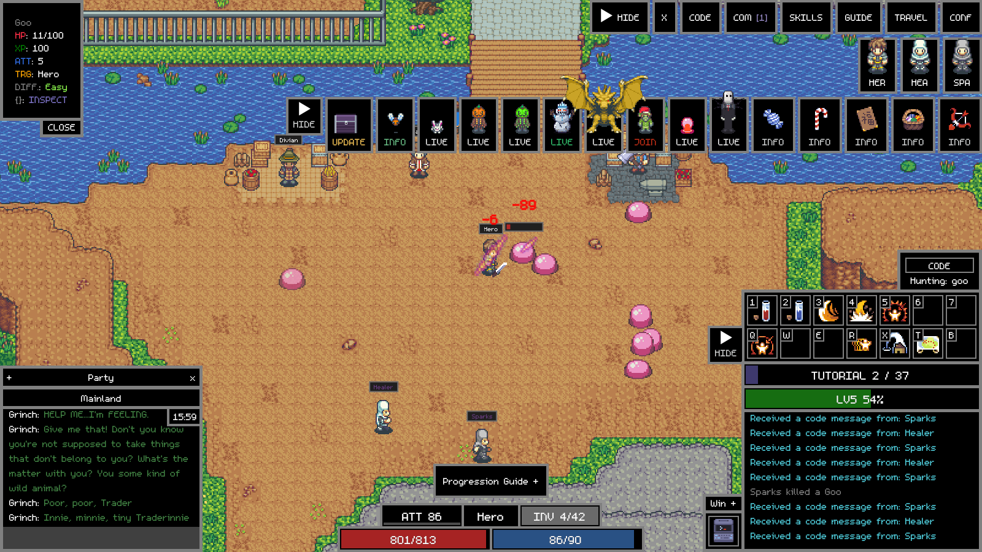
Figure 25. Party AIO running: Hero (Warrior, the leader) fights a Goo while Healer (Priest) and Sparks (Mage) assist. The CODE box shows "Hunting: goo" and the party portraits are top right.

10.1 Setting it up, step by step
- Create your characters, for example a Warrior, a Priest, a Mage and a Merchant.
- On any character, open CODE, press Load and click [Default] Party AIO. The whole script appears in the editor.
- Scroll to the PARTY section near the top. Type your leader's name between the quotes in var LEADER = "";.
- In var FOLLOWERS = [ ]; add one line per follower, each name in quotes followed by a comma. Remove the // in front of the example lines or type your own.
- In var ROLES = { ... } put each character's name in the list for its role, in quotes. Put your merchant under MERCHANT.
- Look through the HUNT SETTINGS and MANUAL MONSTER ROTATION (10.6) and pick monsters your characters can handle.
- Press Save. Your names are now kept in your own Party AIO slot, shared by every character.
- Open a window for each character (Win +, Deploy or /window Name). In each one, open CODE, load [Default] Party AIO and press Engage!. Start the merchant too: it just logs that it is the merchant.
The PARTY and ROLES sections filled in for the party in the pictures
var LEADER = "Hero";

var FOLLOWERS = [
"Healer",
"Sparks",
];

var ROLES = {
WARRIOR: ["Hero"],
PALADIN: [],
ROGUE: [],
MAGE: ["Sparks"],
RANGER: [],
PRIEST: ["Healer"],
MERCHANT: ["Trader"]
};

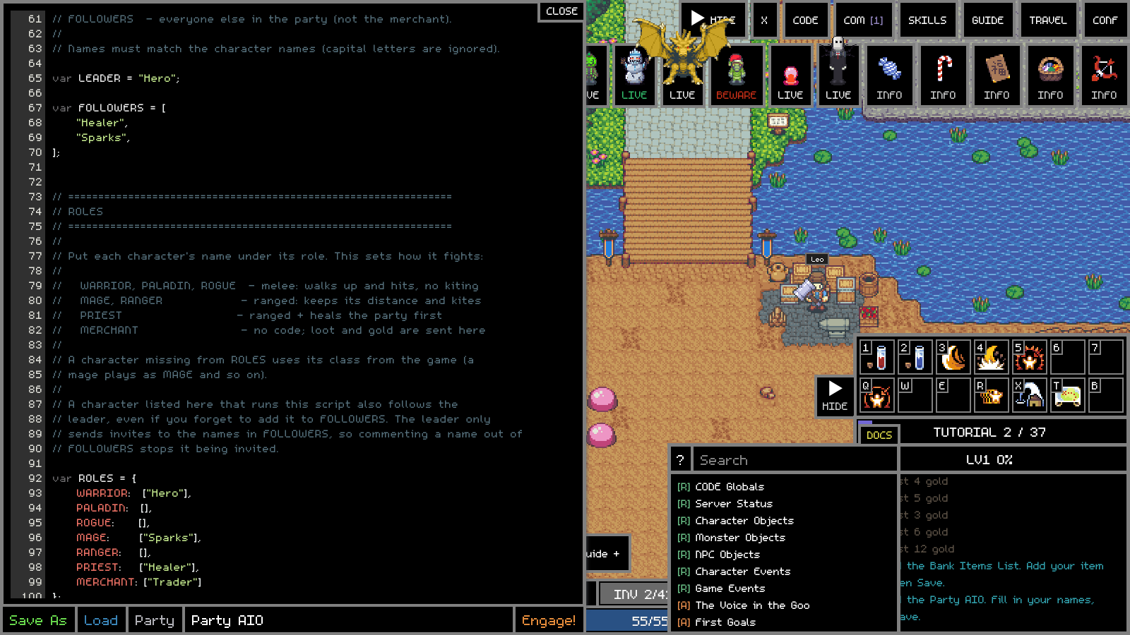
Figure 26. The same settings in the editor.
When each character starts, it writes what it understood in its game log, for example:
The leader's start-up messages
BANK LIST: 0 item id(s) from Bank Items List.
PARTY: Hero is the LEADER, role WARRIOR (melee)
SETTINGS: HP potion below 65%, MP potion below 40%, restock under 30 HP / 30 MP potions.
PARTY HUNTER STARTED
HUNT MODE: Manual
MANUAL MONSTER ROTATION:
goo x 100
bee x 100
MERCHANT: Trader

A follower says PARTY: Healer is a FOLLOWER of Hero, role PRIEST (ranged / kiting) and HUNT MODE: Following Hero. The merchant says PARTY: Trader is the MERCHANT (no code runs). A character that is not named anywhere says it is hunting solo. If what it says is not what you meant, check the spelling of the names.
Tip: Names are matched without caring about capital letters, but spelling must be exact.
Leave LEADER empty and every character simply hunts on its own, using the same monster list. That is a quick way to use Party AIO with a single character.
A character missing from ROLES uses its own class (a mage plays as MAGE). A character listed under a fighting role still follows the leader even if you forgot to add it to FOLLOWERS, but the leader only sends invites to names in FOLLOWERS.

10.2 What every character does, in order
Four times a second (COMBAT_INTERVAL = 250 ms) each character runs one tick of its main hunt loop. A tick does the first thing on this list that applies, then stops until the next tick:
Step | What happens | Who
1. Dead? | Respawn in town, then carry on. (A separate monitor also checks every second.) | Everyone
2. Potions | Drink an HP potion below HP_USE_PERCENT (65%) and an MP potion below MP_USE_PERCENT (40%). | Everyone
3. Potion supply | Fewer than MIN_HP_POTIONS or MIN_MP_POTIONS left? Teleport to town, walk to the potion shop and buy back up to TARGET_HP_POTIONS / TARGET_MP_POTIONS. | Everyone
4. Event loot | If an event boss just died, stay a few seconds and collect its chests. | Everyone
5. Event monster | If a watched event monster is alive, hunt it instead of the normal monster. | Leader / solo
6. Daisy | If on Daisy assignments and the hunt is finished (or missing), go to Daisy for a new one. | Leader / solo
7. Bag full? | MIN_EMPTY_SLOTS (1) or fewer empty slots: teleport to town, give loot and gold to the merchant, then bank. | Everyone
8. Heal | If party members are hurt, heal them (Party Heal when several are low). | Priest
9. Follow | Follow the leader and attack its target (10.4). | Followers
10. Hunt | Pick the monster, find the nearest one, wait for the party, then fight it (10.3). | Leader / solo

Alongside the main loop, some smaller timers run on their own: party invites every 5 seconds, the leader's "what we are doing" message every second, smart skills, the follow watcher, the stuck watchdog, and potions and healing while travelling.

10.3 The leader: choosing, meeting and fighting

Choosing the monster
The leader hunts, in order of priority: a live event monster from EVENT_MONSTERS (if EVENT_MONSTERS_ENABLED), then Daisy's current monster hunt if GET_ASSIGNMENT is true, otherwise the current entry of MANUAL_MONSTER_LIST. Kills by followers count towards the manual list too.

The meeting spot
Telling everyone to smart_move("bee") would send each character to a random bee spawn, possibly on different maps. So the leader picks one spawn area for the monster (the closest one on the leader's map, otherwise the first in the game's list) and keeps it until the monster changes. It tells the party: "I'm going here, meet you there". Followers path straight to that spot rather than chasing the leader.

Waiting for the party
With LEADER_WAITS_FOR_PARTY = true, when the leader finds a monster it holds off starting the fight until every follower is within PARTY_GATHER_DISTANCE (300). The CODE box shows "Waiting for Healer, Sparks". It does not wait for followers who are offline, not in the party, dead, or busy in town restocking or banking (they come to the spot afterwards). It waits at most PARTY_WAIT_MAX_SECONDS (120) and it always fights back if a monster attacks it.
While travelling with MATCH_PARTY_SPEED = true, the leader slows down to just under the slowest follower's speed so nobody falls behind, and goes back to full speed when it arrives.

Fighting
The leader targets the nearest monster of the chosen type, preferring one that is already attacking it. It tells the followers the target's id straight away. A melee leader walks half the distance each tick until in range, then attacks; a ranged leader keeps its distance (10.5). If a wall or river is in the way, it paths round it. It loots before and after each attack.

10.4 Followers: following and assisting
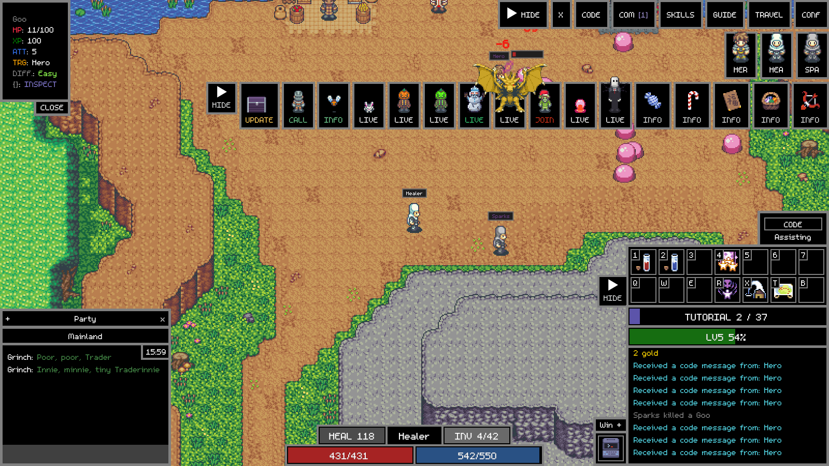
Figure 27. Healer (the Priest follower) in its own window. The CODE box shows "Assisting": it is following Hero and helping with Hero's target.
Each tick a follower works out where the leader is: if it can see the leader, its exact spot; otherwise the party list (which knows every member's map and position), or the leader's last message.
- Far away or on another map: smart_move to the meeting spot or to wherever the leader is heading ("Meeting Hero at main"). It does not stop to fight things left behind.
- At the meeting spot but the leader is not there yet: wait there ("Waiting for Hero at the spot"), defending itself if attacked.
- Near the leader: pick a target and fight it ("Assisting Hero: goo").
- Nothing to fight: stay close. Further than FOLLOW_FAR_DISTANCE (300): smart_move to the leader. Further than FOLLOW_DISTANCE (75): walk a third of the way towards it each tick, going round obstacles.
- Kited too far: further than LEASH_DISTANCE (250) from the leader while fighting, go back first.

Which monster a follower attacks
- Whatever the leader is attacking right now.
- Otherwise, the target the leader last told it about.
- Otherwise, if FOLLOWERS_DEFEND is true, anything attacking it or another party member, as long as it is within ASSIST_RANGE (350) of the leader.
- Otherwise, only if FOLLOWERS_PULL is true, the nearest monster of the leader's type near the leader.
With FOLLOWERS_PULL = false (the default) followers never start a fight on their own: the fight starts when the leader starts it.

Joining the party
Every PARTY_INVITE_SECONDS (5) the leader invites any follower in FOLLOWERS that is online and not yet in the party. A follower accepts invites only from the leader. A follower that is not in a party asks the leader to invite it, and one that is in someone else's party leaves it.

The follow watcher
Twice a second, while a follower is pathing, a watcher checks the path still makes sense and stops it so the next tick can choose a better one when: the leader is now close and in sight (walk the rest), the leader changed where it is going, the meeting spot changed, or the leader moved more than FOLLOW_REPATH_DISTANCE (250) from where the follower was heading.

10.5 Roles and fighting styles
Role | Style | What it does
WARRIOR, PALADIN, ROGUE | Melee | Walks up to the target and hits it. No kiting.
MAGE, RANGER | Ranged | Stays at its preferred distance (its range minus RANGE_BUFFER 10) and kites.
PRIEST | Ranged + healer | Heals the party first, then attacks the leader's target if PRIEST_ATTACKS is true. Carries more potions.
MERCHANT | None | Runs no code. Loot and gold are sent to it.

How kiting works
- Closer than MIN_SAFE_DISTANCE (15): step straight back KITE_STEP (80) pixels.
- Further than preferred range + RANGE_TOLERANCE (15): walk half the distance closer.
- Too close but not dangerously: step back or sideways, switching direction every STRAFE_SWITCH_TIME (2.5 seconds) so it circles rather than walking into a wall.
- It attacks whenever the target is within its real range, even while repositioning.

Healing (Priest)
The Priest looks at every party member nearby. If at least PRIEST_PARTY_HEAL_COUNT (2) are at or below PRIEST_PARTY_HEAL_PERCENT (60%) it uses Party Heal. Otherwise it heals whoever has the lowest HP%, if that is at or below PRIEST_HEAL_PERCENT (75%). It keeps healing while travelling too. A following Priest that has lost sight of the leader goes to the leader first.

Smart skills
On its own timer, each character checks which of its class skills it can use right now (level, MP, cooldown, the right weapon, any item the skill uses up) and uses them when the situation calls for it. Damage skills are not used below SKILL_MP_RESERVE_PERCENT (30%) MP, so there is always MP left for taunts and heals, and they are not wasted on a monster one more hit would finish. Area skills are only used when nothing idle is in range, so they do not pull extra monsters. Set USE_SKILLS = false for plain attacks only (heals still work), or set any single skill in SKILLS to false.
Class | Skill | When Party AIO uses it
Warrior | taunt / agitate | Pull a monster off a party member / taunt everything nearby (only if nothing idle is in range)
Warrior | hardshell, warcry, charge | Below 40% HP while being hit / party buff when a fight starts / speed boost while travelling
Warrior | stomp, cleave | 2+ monsters on the party (needs a basher) / 3+ close by (needs an axe or scythe)
Mage | energize, reflection, burst | Give MP to a low party member / shield whoever is being hit / burst is off by default (uses all MP)
Ranger | huntersmark, supershot, 3shot, 5shot | Mark the target / big long-range hit / 3+ or 5+ monsters on the party
Rogue | quickstab, quickpunch, mentalburst, rspeed | Extra stab (dagger) / punch (fist weapon) / magic hit / speed buff on party members
Priest | curse, darkblessing | Weaken the target / party damage buff when a fight starts
Paladin | selfheal, smash, purify | Below 50% HP / extra hit with a mace / 2000 pure damage on a big monster

10.6 Hunt settings: what to kill
Only the leader (or a solo character) uses these. Followers hunt whatever the leader hunts.

Manual rotation
GET_ASSIGNMENT = false uses MANUAL_MONSTER_LIST: kill the given number of the first monster, then move to the next, and loop back to the start after the last one. The list in the script has one line for almost every monster, most of them switched off with //. Remove the // from the ones you want and put // in front of the rest.
Hunt 100 Goos, then 100 Bees, then Goos again
var MANUAL_MONSTER_LIST = [
{ type: "goo", kills: 100 },
{ type: "bee", kills: 100 },
// { type: "crab", kills: 100 },
];

Watch out: Every active line except the last needs a comma at the end. A missing comma stops the whole script with a syntax error.
The original list has armadillo, bee, rat, spider, squig and tortoise switched on. Some of those are too strong for brand new characters; start with goo, bee or crab.

Daisy assignments
GET_ASSIGNMENT = true makes the leader do Daisy's monster hunts: it goes to Daisy, takes a hunt, kills the monster until the hunt count reaches zero, banks, and fetches the next hunt. The CODE box shows the monster and how many are left.

Event monsters
EVENT_MONSTERS lists bosses that only appear during events (Mr Pumpkin and Mr Green are switched on in the script). If one of them is alive, the leader drops what it is doing and goes to kill it, and the followers come along. If two are alive it finishes the one it started. After the kill everyone stays to collect the chests (between EVENT_LOOT_MIN_SECONDS 4 and EVENT_LOOT_SECONDS 25), then the party carries on exactly where it left off; the manual kill count or Daisy's hunt is untouched.
Watch out: Event bosses are very strong. With new characters set EVENT_MONSTERS_ENABLED = false, switch those monsters off in the Mod Menu, or turn on God Mode. The party in the pictures used EVENT_MONSTERS_ENABLED = false.

10.7 Potions
Setting | Default | Meaning
HP_USE_PERCENT | 65 | Drink an HP potion (hpot1) below this % of max HP
MP_USE_PERCENT | 40 | Drink an MP potion (mpot1) below this % of max MP
MIN_HP_POTIONS / MIN_MP_POTIONS | 30 / 30 | Restock when fewer than this are left
TARGET_HP_POTIONS / TARGET_MP_POTIONS | 5000 / 5000 | Buy back up to this many
PRIEST_MIN_... / PRIEST_TARGET_... | 100, 200 / 10000, 20000 | The Priest's own amounts (it uses more MP)

Restocking teleports to town, walks to the potion shop and buys the difference. Make sure the character keeps enough gold (see GOLD_TO_KEEP below); 5000 potions at 100 gold each is 500,000 gold.

10.8 Inventory: loot, the merchant and the bank
When a character's bag has MIN_EMPTY_SLOTS (1) or fewer empty slots, it does a cleanup trip:
- Teleport to town (and, if it was on another map, travel on to the mainland town).
- If anything in the bag should go to the merchant, look for the merchant (it must be within 100 of the character). Hand over those items, then send gold above GOLD_TO_KEEP. If the merchant cannot be found, skip this step and carry on.
- If anything should be banked, walk to the bank and store it: first every item on the Bank Items List (Chapter 11), then everything else the bank settings say to bank.
- If the bank is full, run the compounder to make room, then carry on banking.
Followers tell the leader they are "busy" during the trip so the leader does not wait for them. Every item is sorted into one category, and two sets of switches decide where each category goes:
Category | Which items | BANK_ default | MERCHANT_ default
POTIONS | Only hpot1 and mpot1 (the potions it drinks) | false | false
TOKENS_COLLECTABLES | Tokens and "collect"/"token" misc items | true | false
STACKABLES | Anything that stacks (materials, scrolls, small potions...) | true | false
UPGRADABLES | Weapons and armour | false | true
COMPOUNDABLES | Rings, earrings, amulets, belts, orbs... | true | false
OTHER_NON_STACKABLES | Anything else that does not stack | false | true

- If neither switch is true for a category, those items stay in the bag. Potions it drinks stay by default.
- Locked items (item.l, locked in the inventory) are always banked and never sent to the merchant.
- Items on the Bank Items List are always banked, whatever their category says, and never go to the merchant.
- Banking is checked again after the merchant hand-over, so nothing is both given away and banked.
Setting | Default | Meaning
SEND_GOLD_TO_MERCHANT | true | Also send gold to the merchant during a cleanup trip
GOLD_TO_KEEP | 1,000,000 | Gold that stays on the character (for potions). Only gold above this is sent
MIN_EMPTY_SLOTS | 1 | Start a cleanup trip at this many empty slots or fewer

10.9 The compounder (when the bank is full)
If storing an item fails because the bank is full and COMPOUND_WHEN_BANK_FULL is true, the compounder runs. It searches the inventory and the whole bank for any three identical compoundable items at the same level below MAX_LEVEL (3), takes exactly what it needs out of the bank, makes sure it has the right scroll (from the bank, or bought from the scroll seller if BUY_MISSING_SCROLLS), and compounds at Cue. Levels 0 and 1 use a Compound Scroll (cscroll0); level 2 and up use a High Compound Scroll (cscroll1) when USE_BETTER_SCROLLS is true. Three items become one, which frees bank space. Leftovers go back in the bank, the character returns to the bank and banking carries on. It runs at most COMPOUND_MAX_RUNS_PER_BANKING (10) times per trip so it can never loop forever, and it only ever runs from inside a banking trip.

10.10 Getting un-stuck
- Path stuck: if a character walking to its hunting area has not made PATH_PROGRESS_DISTANCE (25) of progress in PATH_STUCK_TIME (6 s), it stops and relocates (PATH_RELOCATE_DISTANCE 200) before trying again; it waits PATH_RETRY_DELAY (8 s) between retries.
- Combat stuck: a ranged character that cannot reach its preferred distance for COMBAT_STUCK_TIME (4 s) moves COMBAT_RELOCATE_DISTANCE (150) and tries again.
- Watchdog: with STUCK_TELEPORT_ENABLED, if a character walking to or fighting a monster has not moved (more than 5 pixels) for STUCK_TELEPORT_SECONDS (60), it stops, teleports to town and paths again. Landing hits counts as progress, so a ranged character standing still and killing things is not "stuck". The watchdog never runs during restocking, banking, the merchant hand-over, Daisy or respawning.

10.11 How the party talks to itself
The characters coordinate with code messages (send_cm). That is why the game log shows "Received a code message from: ..." several times a second; it is normal. To hide those lines, add code_settings.log_cm = false; as the first line of Party AIO (or type it into the X snippet runner while the script runs); the messages still arrive, they just are not logged.
Message | From → to | Carries
party_state | Leader → followers, every second and on each new target | Monster type, target id, where the leader is heading, the meeting spot, its map and position
member_speed | Follower → leader, every few seconds | The follower's speed and status: busy (in town), heading (on the way) or here
party_kill | Follower → leader, on each kill | The monster type, so the leader can count it towards the manual list

10.12 Common messages and what they mean
Message | Meaning
PARTY: Waiting for X to catch up. | The leader found a monster and is waiting for X to reach the meeting spot.
HUNT: Completed 100x goo. Moving to next monster. | The manual kill count was reached.
POTIONS: Restocking. HP=12 MP=30 | Below the minimum; going to buy potions.
HUNTER: Inventory getting full. | Starting a cleanup trip.
MERCHANT: Could not find Trader / CLEANUP: Trader unavailable | The merchant was not online or not near town; items go to the bank instead.
BANK OK: ... / BANK FAILED: ... | Each item stored, or why one could not be.
BANK: Bank is full - running the compounder to free space. | The compounder is about to run.
HUNTER: Character killed - respawning. | It died; it respawns and carries on.
PARTY: In X's party, not Hero's - leaving. | A follower was in the wrong party and is leaving it to rejoin the leader.
BANK LIST: 3 item id(s) from Bank Items List. | The Bank Items List was read at start-up.

10.13 Your copy, updates and Reset
Your Party AIO, with your names, is saved in its own slot. To run the version that came with the game (for example after updating Adventure Land), press Reset next to [Default] Party AIO, Confirm, copy your LEADER, FOLLOWERS, ROLES and monster list across from your notes, then Save. Until you Save, your old copy is still what runs. load_code("Party AIO") runs your copy from any script.

10.14 Party AIO settings at a glance
Setting | Default | What it controls
FOLLOW_DISTANCE | 75 | Followers walk towards the leader when further than this
FOLLOW_FAR_DISTANCE | 300 | Further than this (or another map): smart_move instead of walking
ASSIST_RANGE | 350 | Followers only defend against monsters within this distance of the leader
LEASH_DISTANCE | 250 | A follower that kited further than this from the leader goes back
FOLLOWERS_DEFEND | true | Followers fight anything hitting the party when the leader has no target
FOLLOWERS_PULL | false | Followers may start fights on the leader's monster type on their own
PARTY_INVITE_SECONDS | 5 | How often invites and requests are re-sent
PARTY_STATE_SECONDS | 1 | How often the leader tells followers what it is doing
MATCH_PARTY_SPEED | true | Leader slows to the slowest follower while travelling
LEADER_WAITS_FOR_PARTY | true | Leader waits for the party before starting a fight
PARTY_GATHER_DISTANCE | 300 | Followers closer than this count as arrived
PARTY_WAIT_MAX_SECONDS | 120 | Longest the leader waits
FOLLOW_REPATH_DISTANCE | 250 | Re-path when the leader has moved this far from the follower's destination
MEET_RADIUS | 150 | Within this of the meeting spot counts as arrived
PRIEST_HEAL_PERCENT | 75 | Heal a member at or below this HP%
PRIEST_PARTY_HEAL_PERCENT / _COUNT | 60 / 2 | Party Heal when this many are at or below this HP%
PRIEST_ATTACKS | true | Priest attacks when nobody needs healing
USE_SKILLS | true | Use class skills
SKILL_MP_RESERVE_PERCENT | 30 | No damage skills below this MP%
GET_ASSIGNMENT | false | true = Daisy's hunts, false = manual list
EVENT_MONSTERS_ENABLED | true | Chase live event monsters in EVENT_MONSTERS
COMBAT_INTERVAL | 250 | Milliseconds between main loop ticks
RANGE_BUFFER / MIN_SAFE_DISTANCE / KITE_STEP / RANGE_TOLERANCE | 10 / 15 / 80 / 15 | Kiting distances
STUCK_TELEPORT_ENABLED / _SECONDS | true / 60 | The watchdog
COMPOUND_WHEN_BANK_FULL / ENABLE_COMPOUND | true / true | Run the compounder when the bank is full
MAX_LEVEL | 3 | Compound items below this level
GET_ITEMS_FROM_BANK / GET_SCROLLS_FROM_BANK / BUY_MISSING_SCROLLS | true | Where the compounder gets items and scrolls

11. The built-in Bank Items List
The Bank Items List is a tiny script with one job: it is the list of item ids that Party AIO must always put in the bank, whatever the BANK_ and MERCHANT_ category switches would otherwise do. Use it for the odd items you want stored safely: a good ring, an amulet, a spell book, a trinket. Every character running Party AIO shares this one list.
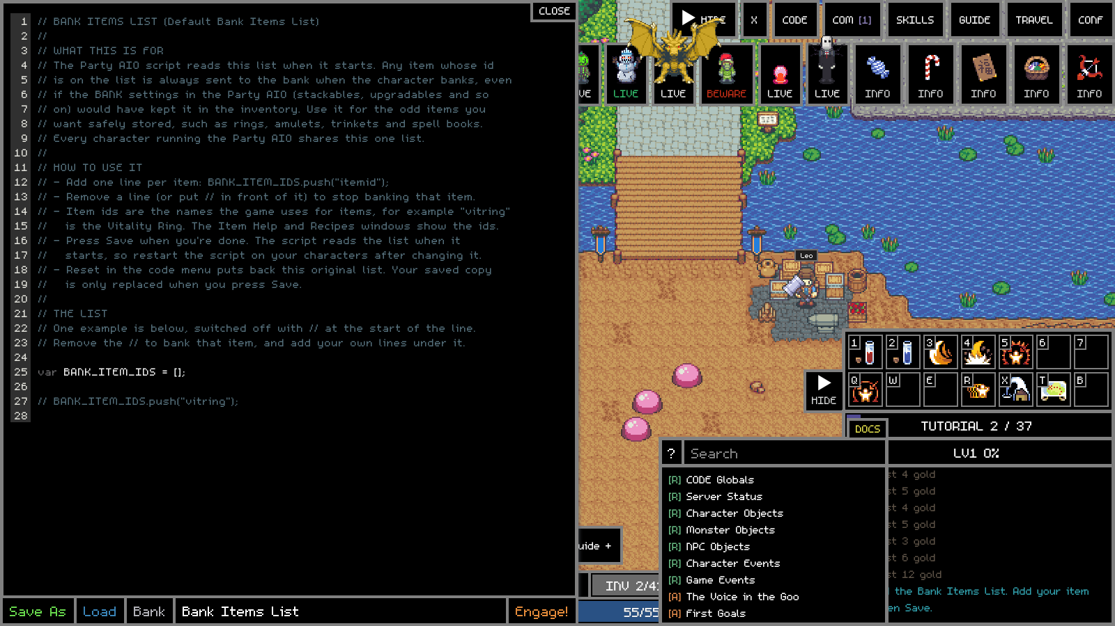
Figure 28. [Default] Bank Items List in the editor.

11.1 What is inside it
The working part of the script
var BANK_ITEM_IDS = [];

// BANK_ITEM_IDS.push("vitring");

The first line makes an empty list. Each BANK_ITEM_IDS.push("itemid"); line adds one item id to it. The example line for the Ring of Vitality (vitring) starts with //, so it is switched off and the list starts empty: nothing extra is banked until you add your own lines.

11.2 Adding your items, step by step
- Find the item id (11.4). Ids are short lower-case names, for example vitring, not the display name "Ring of Vitality".
- Open CODE, press Load, click [Default] Bank Items List.
- Under the example, add one line per item: BANK_ITEM_IDS.push("itemid");
- Press Save.
- Restart Party AIO on your characters (Disengage, then Engage). The list is only read when Party AIO starts.
- Check each character's log for BANK LIST: 3 item id(s) from Bank Items List. with your count.
A filled-in list
var BANK_ITEM_IDS = [];

BANK_ITEM_IDS.push("vitring"); // Ring of Vitality
BANK_ITEM_IDS.push("intring"); // Ring of Intelligence
BANK_ITEM_IDS.push("wbook0"); // Book of Knowledge
// BANK_ITEM_IDS.push("hpamulet"); // switched off for now

To stop banking an item, delete its line or put // in front of it. Capital letters and spaces around the id do not matter, but the spelling must be exact. A misspelt id is simply never matched; nothing breaks.

11.3 How Party AIO uses the list

Loading
Near the top of Party AIO, under INDIVIDUAL ITEMS TO BANK:
var BANK_LIST_CODE = "Bank Items List";
var BANK_ITEM_IDS = [];
try {
load_code(BANK_LIST_CODE);
} catch (e) {
game_log("BANK LIST: could not load " + BANK_LIST_CODE + " (" + e + ")");
}
game_log("BANK LIST: " + BANK_ITEM_IDS.length + " item id(s) from " + BANK_LIST_CODE + ".");

load_code runs your saved Bank Items List inside Party AIO, which fills BANK_ITEM_IDS. If it cannot be loaded, Party AIO logs why and carries on with an empty list. If you have your own slot called "Bank Items List" from before, Party AIO keeps using that until you save the default one.

Matching
For every item in the bag, Party AIO compares the item's id with every id on the list (both lower-cased, spaces trimmed). A match makes the item an individual bank item.

The rules, in order
When Party AIO decides where an item goes during a cleanup trip:
Check | Bank it? | Give to merchant?
Item is locked (item.l) | Yes, always | Never
Item id is on the Bank Items List | Yes, always | Never
Otherwise, by category | BANK_<category> switch | MERCHANT_<category> switch

The banking order
- At the bank, Party AIO first goes through the Bank Items List in order, storing every matching item in the bag (all copies of each).
- Then it banks everything else that the category switches say to bank, skipping list items (they are already done and must never fall through to another destination).
- If the bank is full at any point, the compounder runs to free space, then banking resumes with the same item.
- If an item still cannot be stored, banking stops for this trip and the log says how many were secured.

It also triggers trips
A non-empty list counts as an "automatic inventory action". Even with every BANK_ and MERCHANT_ switch set to false, a cleanup trip still happens when the bag is full and a listed item is in it.
Tip: The list protects items from being handed to the merchant. With the default MERCHANT_UPGRADABLES = true, every weapon and armour piece goes to your merchant; put the id of one you want kept on the Bank Items List and it goes to the bank instead.

11.4 Finding item ids
- Open GUIDE > All Items to browse every item and find the one you want; then confirm its id with one of the CODE methods below.
- In CODE: show_json(character.items) shows the bag, and each entry's name is its id. game_log(character.items[0].name) prints the id of the first slot.
- Search the game data: for (var id in G.items) if (G.items[id].name == "Ring of Vitality") game_log(id);
- Appendix B has a short list of common ids.

11.5 Reset
Reset next to [Default] Bank Items List, then Confirm, puts the original list (with its single switched-off example) back in the editor. Your saved list is only replaced when you press Save.

12. Writing your own scripts, step by step
The best way to learn is to build a script a little at a time and run it after every step. Each step below is a complete script: paste it into an empty slot (Save As a new number), Engage, watch, Disengage, and move to the next.

12.1 Step 1: say hello and show some facts
game_log("Hello, I am " + character.name + ", a level " + character.level + " " + character.ctype);
game_log("I have " + character.gold + " gold and " + character.hp + "/" + character.max_hp + " HP");
game_log("I am on the map " + character.map + " at " + Math.round(character.x) + ", " + Math.round(character.y));

Nothing repeats, so the script runs once. Every line writes something to the log. If you see an error, compare your typing with the example character by character.

12.2 Step 2: a loop that keeps you alive
setInterval(function () {
if (character.rip) { // dead?
respawn();
return;
}
if (character.hp < character.max_hp * 0.6 && !is_on_cooldown("use_hp")) {
use_skill("use_hp");
} else if (character.mp < character.max_mp * 0.3 && !is_on_cooldown("use_mp")) {
use_skill("use_mp");
}
loot();
set_message("HP " + Math.round(character.hp / character.max_hp * 100) + "%");
}, 250);

Now fight by hand while it runs: it drinks potions for you, loots chests and shows your HP% in the CODE box.

12.3 Step 3: fight the nearest monster of one type
var MONSTER = "goo";

setInterval(function () {
if (character.rip) { respawn(); return; }
use_hp_or_mp();
loot();
if (is_moving(character)) return;

var target = get_targeted_monster();
if (!target || target.mtype != MONSTER) {
target = get_nearest_monster({ type: MONSTER });
if (!target) { set_message("No " + MONSTER + " here"); return; }
change_target(target);
}

if (!is_in_range(target)) {
move(character.x + (target.x - character.x) / 2,
character.y + (target.y - character.y) / 2);
} else if (can_attack(target)) {
set_message("Attacking " + MONSTER);
attack(target);
}
}, 250);

12.4 Step 4: walk to the monsters if none are near
smart_move("goo") finds a path to where goos live, even from another map. Because it takes time, we keep a flag so the loop does not start a second trip while the first is under way.
var MONSTER = "goo";
var travelling = false;

setInterval(function () {
if (character.rip) { respawn(); return; }
use_hp_or_mp();
loot();
if (travelling || is_moving(character)) return;

var target = get_nearest_monster({ type: MONSTER });
if (!target) {
travelling = true;
set_message("Walking to " + MONSTER);
smart_move(MONSTER)
.catch(function (e) { game_log("Path failed: " + e.reason); })
.finally(function () { travelling = false; });
return;
}
change_target(target);
if (!is_in_range(target)) move(character.x + (target.x - character.x) / 2, character.y + (target.y - character.y) / 2);
else if (can_attack(target)) attack(target);
}, 250);

12.5 Step 5: restock potions when low
var busy = false;

async function restock() {
busy = true;
try {
set_message("Restocking");
await smart_move("potions");
var need = 200 - quantity("hpot0");
if (need > 0) await buy("hpot0", need);
need = 200 - quantity("mpot0");
if (need > 0) await buy("mpot0", need);
game_log("Restocked");
} catch (e) {
game_log("Restock failed: " + (e.reason || e));
}
busy = false;
}

setInterval(function () {
if (busy) return;
if (quantity("hpot0") < 20 || quantity("mpot0") < 20) restock();
// ... the hunting code from step 4 goes here ...
}, 250);

12.6 Step 6: put loot in the bank when the bag is full
async function bank_everything_but_potions() {
await smart_move("bank");
for (var i = 0; i < character.items.length; i++) {
var item = character.items[i];
if (!item) continue;
if (item.name.startsWith("hpot") || item.name.startsWith("mpot")) continue;
try { await bank_store(i); } catch (e) { game_log("Could not bank " + item.name); }
}
game_log("Banking done");
}

function empty_slots() {
var n = 0;
for (var i = 0; i < character.items.length; i++) if (!character.items[i]) n++;
return n;
}
// In the loop: if (!busy && empty_slots() < 3) { busy = true; bank_everything_but_potions().finally(function () { busy = false; }); }

12.7 Step 7: use a skill
// Warrior: taunt a monster that is attacking someone else in the party
var t = get_targeted_monster();
if (t && t.target && t.target != character.name && !is_on_cooldown("taunt")) {
use_skill("taunt", t);
}

// Priest: heal the most hurt party member in range
var worst = null;
for (var name in get_party()) {
var p = get_player(name);
if (p && !p.rip && p.hp < p.max_hp * 0.7 && (!worst || p.hp / p.max_hp < worst.hp / worst.max_hp)) worst = p;
}
if (worst && is_in_range(worst, "heal") && !is_on_cooldown("heal")) heal(worst);

12.8 Step 8: two characters working together
// On the fighter: send all gold over 100,000 to the merchant when it is nearby
var MERCHANT = "Trader";
setInterval(function () {
var m = get_player(MERCHANT);
if (m && distance(character, m) < 300 && character.gold > 100000) {
send_gold(MERCHANT, character.gold - 100000);
}
}, 5000);

// Ask the merchant (running its own CODE) to come here
send_cm(MERCHANT, { come: { map: character.map, x: character.x, y: character.y } });

// On the merchant:
character.on("cm", function (m) {
if (m.message.come) smart_move(m.message.come);
});

12.9 Building on Party AIO instead
Often the quickest route is to change Party AIO's settings rather than write a script from scratch. Some ideas:
- A solo grinder: leave LEADER empty, set MANUAL_MONSTER_LIST, start it on one character.
- A Daisy farmer: set GET_ASSIGNMENT = true on the leader.
- Keep all weapons: set MERCHANT_UPGRADABLES = false and BANK_UPGRADABLES = true.
- No merchant: leave MERCHANT empty; everything that would go to the merchant stays in the bag or is banked by the BANK_ switches.
- Ranged melee? Put a Warrior under MAGE in ROLES and it will kite (not recommended, but it shows how roles work).
Tip: Keep your own changes in comments with your initials, for example // BOSS: was 65, so you can find them again after a Reset.

13. Troubleshooting and tips
Problem | What to check
The game will not start | Run Play.bat to see the console messages. Check Node.js and MongoDB are installed. Make sure an older Adventure Land is not still open. Look in the logs folder.
"Windows protected your PC" | More info, then Run anyway. Only asked once.
A new window is turned away | Characters online in the Mod Menu is too low, or 2 merchants are already online. The window's log says which.
The script does nothing | Did you press Engage? Is the CODE box showing a message? Look for a red error in the game log and the line number.
SyntaxError on Engage | A missing comma, bracket or quote. Very often a missing comma at the end of a MANUAL_MONSTER_LIST or FOLLOWERS line.
Followers do not follow | Check the names in LEADER, FOLLOWERS and ROLES, and each follower's start-up log line. All characters must run Party AIO and be online. The leader must be running too.
The leader keeps waiting | A follower is far away, stuck or dead. After 120 seconds the leader goes ahead anyway. Lower PARTY_WAIT_MAX_SECONDS or set LEADER_WAITS_FOR_PARTY = false.
The party runs off to a boss and dies | An event monster is alive. Set EVENT_MONSTERS_ENABLED = false, switch the monster off in the Mod Menu, or turn on God Mode.
Characters keep dying | Pick easier monsters, lower HP loss in the Mod Menu, raise HP_USE_PERCENT, add a Priest, or use God Mode.
Loot is not reaching the merchant | The merchant must be online and standing in town near where characters teleport (the town square). Check MERCHANT_ settings.
Bank Items List items are not banked | Check the ids (lower-case game ids, not display names), press Save, and restart Party AIO. Look for the BANK LIST line in the log.
"Received a code message" fills the log | Normal while Party AIO runs; it is how the party talks to itself. Add code_settings.log_cm = false; at the top of the script to stop logging them.
The skill boxes, tools or events disappeared | They were folded with HIDE. Click SKILLS, TOOLS or EVENTS at the right-hand edge of the screen.
Everything is slow | Close some windows. Each character window costs memory and processor time.

13.1 Good habits
- Change one thing at a time and run it, so you know what caused any problem.
- Use game_log generously while you are building something, then remove the noisy lines.
- Save working versions in separate slots before big changes.
- Back up singleplayer\data and settings.txt now and then (with the game closed).
- Read the scripts that come with the game. Party AIO is long, but every section has a comment explaining it.

Appendix A. CODE function reference, one example each
Each entry shows the function, what it does, and a single example you can paste into the CODE window. Functions marked returns a Promise take time; use await inside an async function, or .then(). Run one-line examples with the X button to try them without disturbing your main script.

A.1 Writing messages and inspecting
game_log(message, color)
Writes a line in the game log. The colour is optional (a name like "red" or a code like "#33AAFF").
game_log("Starting the hunt", "lime");

set_message(text)
Shows a short status in the CODE box above the skill boxes.
set_message("Killing goos: " + kills);

show_json(anything)
Opens a window showing an object's contents. Great for exploring.
show_json(character.slots); // what am I wearing?

say(message) / party_say(message) / pm(name, message)
Speak in local chat, in party chat, or privately to one character.
party_say("Pulling the next one!");

draw_circle(x, y, radius) / draw_line(x1, y1, x2, y2) / clear_drawings()
Draw on the map (for your own eyes) and clear the drawings.
draw_circle(character.x, character.y, character.range); // show my attack range

A.2 Finding things
get_nearest_monster(args)
The closest monster matching optional filters: type, min_xp, max_att, target (only ones attacking that name), no_target, path_check. Returns null if none.
var m = get_nearest_monster({ type: "bee", max_att: 50 });
if (m) change_target(m);

get_targeted_monster()
The monster you have selected, or null.
var t = get_targeted_monster();
if (t) game_log(t.mtype + " has " + t.hp + " HP");

get_target_of(entity)
Whatever that entity has selected. Useful for followers.
var leader = get_player("Hero");
var t = get_target_of(leader);
if (t) attack(t);

get_player(name)
Another player character on your map that you can see, or null.
var healer = get_player("Healer");
if (healer) game_log("Healer is " + Math.round(distance(character, healer)) + " away");

get_monster(id)
A monster by its id, if it is in sight.
var m = get_monster(character.target);

get_nearest_hostile(args)
The nearest player that could be hostile. Mostly for PvP; rarely needed in single player.
var h = get_nearest_hostile({});

find_npc(id)
Where an NPC stands: {map, x, y}.
var ponty = find_npc("secondhands");
smart_move({ map: ponty.map, x: ponty.x, y: ponty.y + 40 });

get_party()
Everyone in your party with their map and position, keyed by name.
for (var name in get_party()) game_log(name + " is on " + get_party()[name].map);

distance(a, b)
Distance between two things that have x and y (characters, monsters, spots).
if (distance(character, target) > 200) game_log("Far away");

parent.entities
Every entity in sight (monsters, players, NPCs), keyed by id.
for (var id in parent.entities) {
var e = parent.entities[id];
if (e.type == "monster" && e.mtype == "goo") game_log("Goo at " + e.x + "," + e.y);
}

A.3 Moving
smart_move(destination)
Finds a path and walks there, across maps if needed. Returns a Promise. The destination can be a monster type ("goo"), a map ("winterland"), a place ("bank", "potions", "scrolls", "upgrade", "compound", "exchange", "town"), an NPC id ("monsterhunter"), or {map, x, y}.
async function go() {
await smart_move("bank");
game_log("Arrived at the bank");
}
go();

move(x, y)
Walks in a straight line towards a spot on the current map. Stops at walls.
move(character.x + 50, character.y); // step 50 to the right

xmove(x, y)
Like move, but switches to smart_move automatically if the straight line is blocked.
xmove(target.x, target.y);

can_move_to(x, y)
true if you can walk there in a straight line.
if (!can_move_to(m.x, m.y)) smart_move({ x: m.x, y: m.y });

stop(action)
Stops something: stop() or stop("move") stops walking, stop("smart") cancels a smart_move.
stop("smart");

is_moving(entity)
true while that entity (often character) is walking.
if (is_moving(character)) return;

use_skill("use_town") / town()
Teleport to the centre of the current map after a short channel.
await use_skill("use_town");

transport(map, spawn)
Use a transporter to another map when standing near one. Returns a Promise.
await transport("winterland", 0);

cruise(speed)
Caps your walking speed (Party AIO uses it so the leader does not outrun the party). A huge number removes the cap.
cruise(40); // walk slowly
cruise(100000); // back to normal

A.4 Fighting
change_target(target)
Selects a monster or player, as if you clicked it.
change_target(get_nearest_monster({ type: "goo" }));

is_in_range(target, skill)
true if the target is within range of your attack (or of a named skill).
if (is_in_range(target)) attack(target);

can_attack(target)
true if the target is valid, in range and your attack cooldown is ready.
if (can_attack(target)) attack(target);

attack(target)
Attacks the target once. Returns a Promise.
attack(target).catch(function (e) { game_log("Missed: " + e.reason); });

heal(target)
Priest: heal a party member (or yourself).
var p = get_player("Hero");
if (p && p.hp < p.max_hp * 0.7) heal(p);

can_heal(target)
true if you can heal that target right now.
if (can_heal(p)) heal(p);

use_skill(name, target, extra)
Uses any skill. Some need a target, some a position. Returns a Promise.
use_skill("taunt", target);
use_skill("partyheal");
use_skill("blink", [character.x + 100, character.y]);

is_on_cooldown(skill)
true while a skill is still cooling down.
if (!is_on_cooldown("supershot")) use_skill("supershot", target);

loot()
Opens every chest in range.
loot();

get_chests()
All chests on the ground near you, keyed by id.
game_log(Object.keys(get_chests()).length + " chests nearby");

respawn()
Respawn in town after dying. Returns a Promise.
if (character.rip) respawn();

A.5 HP, MP and potions
use_hp_or_mp()
Drinks an HP or MP potion if either is low (the game's own simple rule).
setInterval(use_hp_or_mp, 500);

use_skill("use_hp") / use_skill("use_mp")
Drink an HP or MP potion now. They share a short cooldown.
if (character.hp < character.max_hp * 0.5) use_skill("use_hp");

use(slot)
Uses the item in an inventory slot (Party AIO drinks potions this way).
var s = locate_item("hpot1");
if (s >= 0) use(s);

A.6 Inventory and items
character.items
Your 42 inventory slots. Each is null or {name, q (quantity), level}.
var first = character.items[0];
if (first) game_log(first.name + " x" + (first.q || 1));

locate_item(name)
The first slot holding that item id, or -1.
var slot = locate_item("scroll0");
if (slot == -1) game_log("No upgrade scrolls");

quantity(name)
How many of an item you carry in total, across all slots.
if (quantity("hpot1") < 50) game_log("Low on potions");

equip(slot, equipment_slot)
Equips the item in an inventory slot. The second argument (for example "ring2") is optional.
equip(locate_item("vitring"), "ring2");

unequip(slot_name)
Takes off what is in an equipment slot.
unequip("offhand");

swap(a, b)
Swaps two inventory slots.
swap(0, 41);

split(slot, quantity)
Splits a stack into two.
split(locate_item("hpot1"), 10);

lock_item(slot) / unlock_item(slot)
Locks an item so it cannot be sold, destroyed or upgraded by accident. Party AIO always banks locked items.
lock_item(locate_item("vitring"));

destroy(slot)
Destroys the item in a slot. There is no undo.
destroy(locate_item("mbones"));

item_grade(item)
0 normal, 1 high, 2 rare (and higher for legendary), or -1 for no item.
if (item_grade(character.items[0]) >= 1) game_log("High grade!");

item_value(item)
What the item is worth in gold.
game_log("Worth " + item_value(character.items[0]));

G.items[id]
The game's data for an item id: name, type, price (g), stats.
game_log(G.items["hpot1"].name + " costs " + G.items["hpot1"].g);

A.7 Shops, gold and trading
buy(name, quantity)
Buys from an NPC shop that sells it (you must be near). Returns a Promise.
await smart_move("potions");
await buy("hpot1", 200);

sell(slot, quantity)
Sells an item to the nearby NPC shop (Gabriel and the others).
sell(locate_item("mbones"), 10);

send_gold(name, amount)
Sends gold to another of your characters nearby. Returns a Promise.
send_gold("Trader", 50000);

send_item(name, slot, quantity)
Gives an item to another character nearby. Returns a Promise.
send_item("Trader", locate_item("beewings"), 50);

exchange(slot)
Exchanges an item at Xyn (or the right NPC) and waits for the reward. Returns a Promise.
await smart_move("exchange");
await exchange(locate_item("armorbox"));

exchange_buy(token, name)
Buys an item with tokens from a token exchange.
exchange_buy("monstertoken", "funtoken");

get_secondhands() / buy_secondhand(rid)
Ponty's stock, and buying one item from it (stand near Ponty). Return Promises.
var stock = await get_secondhands();
show_json(stock);

open_stand(slot) / close_stand()
Merchant: open or close the market stall (needs a Merchant Stand).
open_stand();

trade(slot, trade_slot, price, quantity)
Merchant: put an inventory item on the stall for sale.
trade(locate_item("vitring"), 1, 250000); // trade slot 1 for 250,000 gold

A.8 Upgrading and compounding
upgrade(item_slot, scroll_slot, offering_slot)
Upgrades an item at Cue. The offering is optional. Returns a Promise that tells you if it succeeded.
await smart_move("upgrade");
var r = await upgrade(locate_item("wbook0"), locate_item("scroll0"));
game_log(r.success ? "Upgraded!" : "Failed");

compound(slot1, slot2, slot3, scroll_slot, offering_slot)
Combines three identical items at the same level. Returns a Promise.
// three Rings of Vitality +0 in slots 3, 4 and 5, a Compound Scroll in slot 10
await compound(3, 4, 5, 10);

upgrade(..., only_calculate) / compound(..., only_calculate)
Pass true as the last argument to get the chance without doing it.
var c = await upgrade(0, 1, null, true);
show_json(c);

A.9 The bank
bank_store(slot, pack, pack_slot)
Stores an inventory item in the bank. Only slot is required. Only works inside the bank. Returns a Promise.
await smart_move("bank");
await bank_store(locate_item("vitring"));

bank_retrieve(pack, pack_slot, inventory_slot)
Takes an item out of a bank pack.
bank_retrieve("items0", 0); // first slot of the first pack

bank_deposit(gold) / bank_withdraw(gold)
Put gold into, or take gold out of, the bank.
bank_deposit(character.gold - 100000);

character.bank
The bank's packs (items0, items1...) while you are inside. Each is an array of slots.
var p = character.bank.items0;
for (var i = 0; i < p.length; i++) if (p[i]) game_log(p[i].name);

A.10 Parties and other characters
send_party_invite(name) / send_party_request(name)
Invite someone to your party, or ask to join theirs.
send_party_invite("Healer");

accept_party_invite(name) / accept_party_request(name)
Accept an invite or a request.
accept_party_invite("Hero");

on_party_invite(name) / on_party_request(name)
Define these functions and the game calls them when an invite or request arrives.
function on_party_invite(name) {
if (name == "Hero") accept_party_invite(name);
}

leave_party() / kick_party_member(name)
Leave your party, or (as leader) remove someone.
leave_party();

send_cm(names, data)
Sends a code message (any data) to one character or a list. Returns a Promise.
send_cm(["Healer", "Sparks"], { go_to: "bee" });

character.on("cm", function)
Receive code messages. m.name is the sender and m.message the data.
character.on("cm", function (m) {
if (m.message.go_to) smart_move(m.message.go_to);
});

start_character(name, slot_or_name)
Starts another of your characters running a script in the background of this window.
start_character("Healer", "Party AIO");

stop_character(name)
Stops a character started with start_character.
stop_character("Healer");

command_character(name, code)
Runs a line of code in another character started with start_character.
command_character("Healer", "smart_move('bank')");

open_character_window(name)
Opens a character in its own new game window. Leave the name out for character select.
open_character_window("Sparks");

get_active_characters()
Which of your characters are running and how, for example {Hero: "self", Healer: "code"}.
show_json(get_active_characters());

is_character_local(name)
true if that character's window is open on this PC.
if (!is_character_local("Trader")) game_log("Trader is offline");

A.11 Events and timing
setInterval(function, ms) / clearInterval(id)
Run something repeatedly; keep the id to stop it later.
var id = setInterval(loot, 500);
// later
clearInterval(id);

setTimeout(function, ms)
Run something once after a delay.
setTimeout(function () { game_log("10 seconds passed"); }, 10000);

sleep(ms)
A pause inside an async function. Returns a Promise.
async function slow() {
game_log("wait...");
await sleep(2000);
game_log("done");
}

wait_for(condition, timeout_ms)
Waits until a function returns true, or the timeout passes. Returns a Promise.
await wait_for(function () { return !is_moving(character); }, 10000);

game.on(event, function)
Listen for game-wide events such as "hit" (anything hit anything) or "death".
game.on("hit", function (d) {
if (d.target == character.id) game_log("Ouch, " + d.damage);
});

character.on(event, function)
Listen for events about your character, such as "cm", "loot" or "new_map".
character.on("loot", function (d) { game_log("Looted a chest"); });

A.12 Code slots, storage and keys
load_code(name_or_slot)
Runs another saved script inside this one.
load_code("Bank Items List");
game_log(BANK_ITEM_IDS.length + " ids loaded");

set(name, value) / get(name)
Store a value (numbers, text, lists, objects) that survives restarting the script.
set("total_kills", (get("total_kills") || 0) + 1);

map_key(key, skill)
Puts a skill on a key (and its skill box).
map_key("6", "supershot");

interact(name)
Talks to special NPCs by action name, for example Daisy's monster hunt.
await smart_move("monsterhunter");
await interact("monsterhunt");

add_top_button(id, label, function)
Adds your own button to the top of the screen.
add_top_button("bank", "BANK", function () { smart_move("bank"); });

Appendix B. Useful ids and names

B.1 Common item ids
Item id | Name | Type
hpot0 / hpot1 | HP Potion (200 / 400 HP) | Potion
mpot0 / mpot1 | MP Potion (300 / 500 MP) | Potion
scroll0 / scroll1 / scroll2 | Upgrade Scroll / High / Rare | Upgrade scroll
cscroll0 / cscroll1 / cscroll2 | Compound Scroll / High / Rare | Compound scroll
offering | Primordial Essence | Optional upgrade booster
vitring, intring, strring, dexring | Rings of Vitality, Intelligence, Strength, Dexterity | Ring
ringsj | Ring of Small Joys | Ring
hpamulet, intamulet, stramulet, dexamulet | Amulets of HP, Intelligence, Strength, Dexterity | Amulet
intearring, strearring, dexearring, vitearring | Earrings | Earring
hpbelt | Belt of HP | Belt
orbg | Orb of Beginnings | Orb
wbook0, wbook1 | Book of Knowledge, Book of Secrets | Off-hand source
seashell | Seashell | Currency for former Shell prices
armorbox, weaponbox | Armor Box, Weapon Box | Exchangeable
gem0 | Raw Emerald | Exchangeable
candy0, candy1 | Rare Candy, Candy | Holiday exchangeable
monstertoken | Monster Token | Daisy's reward token
beewings, gslime, spidersilk, mbones | Bee Wings, Slime Core, Spider Silk, Bones | Materials
stand0 | Merchant Stand | Merchant stall
rod, pickaxe | Fishing Rod, Pickaxe | Gathering tools

B.2 Monster ids for hunting
Id | Name | HP | Attack | XP
goo | Goo | 100 | 5 | 100
bee | Bee | 300 | 16 | 400
crab | Tiny Crab | 400 | 24 | 500
minimush | Pom Pom | 500 | 120 | 600
snake | Snake | 720 | 24 | 960
rat | Rat | 820 | 80 | 640
squig | Squig | 1,000 | 7 | 600
armadillo | Armadillo | 1,600 | 20 | 1,720
arcticbee | Arctic Bee | 1,600 | 64 | 1,800
croc | Croc | 3,200 | 48 | 3,600
poisio | Poisio | 3,600 | 240 | 4,000
iceroamer | Water Spirit | 3,600 | 120 | 4,200
tortoise | Tortoise | 7,200 | 36 | 5,200
bat | Bat | 9,600 | 50 | 8,000
boar | Wild Boar | 12,000 | 240 | 10,800
ghost | Ghost | 12,000 | 200 | 16,000
mummy | Mummy | 12,000 | 420 | 16,000
spider | Spider | 18,000 | 80 | 12,000
scorpion | Scorpion | 24,000 | 100 | 20,000
bigbird | Hawk | 32,000 | 480 | 30,000
wolf | White Wolf | 48,000 | 480 | 48,800

Event monsters
Id | Name | HP | Note
mrpumpkin, mrgreen | Mr. Pumpkin, Mr. Green | 36,000,000 | Halloween bosses. Need a strong party.
grinch | Grinch | 24,000,000 | Holiday season. Steals gold in town.
dragold | Dragold | 25,600,000 | Lunar New Year dragon in the Cave of Darkness.
slenderman | Slenderman | 66,666 | Hits very hard (3,600).
snowman | Snowman | 1,200 | Holiday season, in Winterland.
pinkgoo | Love Goo | 40 | Valentine's.
wabbit | Wabbit | 32,000 | Egg Hunt. Huge XP.

B.3 smart_move place names
Name | Goes to
"town" or "main" | The Mainland town centre
"bank" | Inside the bank
"potions" | The potion shop (the nearest one on Halloween and Winterland maps)
"scrolls" | Lucas, the scroll seller
"upgrade" / "compound" | Cue, the upgrade and compound NPC
"exchange" | Xyn, the exchange NPC
"monsterhunter" | Daisy
any monster id | A spawn area of that monster (a random one each time)
any map id | That map, for example "winterland", "desertland", "halloween"
{ map: "main", x: 0, y: 0 } | An exact spot

Appendix C. Every setting in settings.txt
Setting | Default | Mod Menu name
sell_multiplier | 1 | Market > Sell Item Price
trader_discount | 0 | Market > Trader Discount %
ponty_restock_minutes | 5 | Market > Ponty Restock minutes
ponty_item_count | 20 | Market > Items per restock
ponty_min_grade | 1 | Market > Lowest grade
ponty_upgrade_level_min / _max | 6 / 9 | Market > Upgrade level from / to
ponty_compound_level_min / _max | 2 / 4 | Market > Compound level from / to
xp_rate | 1 | Combat > XP multiplier
damage_rate | 1 | Combat > Damage multiplier
hp_loss | 1 | Combat > HP loss
mp_usage | 1 | Combat > MP usage
skill_cooldown | 1 | Combat > Skill cooldowns
death_penalty | 1 | Combat > Death penalty
upgrade_success / compound_success | 1 / 1 | Crafting > Upgrade luck / Compound luck
safe_upgrades | no | Crafting > Safe upgrades
drop_rate | 1 | Loot > Drop luck
gold_drop | 1 | Loot > Gold dropped
drop_everything | no | Loot > Drop everything
exchange_luck | 1 | Loot > Exchange luck
exchange_speed | 1 | Loot > Exchange speed
crafting_speed | 1 | Crafting > Crafting speed
monster_hunt_tokens | 1 | Monsters > Daisy's tokens
monster_respawn | 1 | Monsters > Respawn time
fire_sale | no | Market > Fire Sale
god_mode | no | Combat > God Mode
holiday_season, lunar_new_year, valentines, halloween, egg_hunt | yes | Holiday Events
monster_grinch, _snowman, _mrpumpkin, _mrgreen, _slenderman, _dragold, _pinkgoo, _wabbit | yes | Monsters > Event Monsters
max_characters_online | 10 | Characters > Characters online
run_speed | 1 | Characters > Run speed
fishing_mining_cooldown | no | Crafting > Fishing and mining wait (restart)
tools_break | no | Crafting > Tools break
starting_gold | 10000000 | Characters > Starting gold
give_gold / give_xp | 1000000 / 100000 | Characters > Give / Take amounts
merrit_visit_minutes | 60 | Market > Merrit Visit minutes (restart)
merrit_buys_stall | yes | Market > Buys your stall

Appendix D. Glossary
Word | Meaning
Aggro | A monster's attention. Taunting pulls aggro onto you.
Array | A list of values in order, counted from 0.
async / await | A way to write code that waits for slow actions (walking, buying) step by step.
Boolean | A true/false value.
Callback | A function you hand to something else to run later, like the function inside setInterval.
Code message (cm) | Data one of your characters sends another through CODE.
Compound | Combine three identical accessories into one of a higher level.
Cooldown | The wait before a skill or attack can be used again.
Engage | Start the script in the CODE editor.
Entity | Anything on the map: a monster, player or NPC.
G | The game's data book: items, monsters, skills, maps.
Grade | Normal, high, rare or legendary. Decides which scroll an item needs.
Kite | Attack while backing away so a melee monster cannot hit you.
Leader / follower | In Party AIO, the character that chooses what to hunt, and the ones that go with it.
Loop / tick | One pass through code that repeats; a tick is one run of a setInterval function.
Melee / ranged | Fights up close / from a distance.
Mod Menu | Adventure Land's in-game settings window for the game's rules.
Object | A set of named values, like { type: "goo", kills: 100 }.
Promise | A ticket for an action that finishes later, and says whether it worked.
Slot | A place in the inventory, an equipment position, or a saved CODE script.
smart_move | Walk somewhere with automatic pathfinding, across maps.
Spawn | Where monsters appear; also, appearing again after being killed.
String | Text, written in quotes.
Upgrade | Raise a weapon or armour piece by one level with a scroll.
Variable | A named box that holds a value.

